Test Administration Manual 2018-2019
Integrated Model States
Publication Date: 08/01/2018

All screenshots, data dictionaries, and templates shown or referred to in this manual are accurate on the publication date noted above.

When this manual is updated, the revision date will also be updated. A summary of changes is included in the Appendix under Document History.
Dynamic Learning Maps® Consortium
Copyright © 2018

ABOUT THIS MANUAL
Although this manual contains a large amount of information, it is important to read it in its entirety. In an effort to effectively sort information for ease of use, the manual is organized into three categories, outlined in the table below.
Category | Information Included
Introduction | Provides an orientation to the Dynamic Learning Maps® (DLM®) project, the assessment system, and the DLM testlets.
Assessment | Provides information on the preassessment process, instructionally embedded assessments, spring assessments, and preparation for future years.
Systems | Provides an overview of Kite® Student Portal, with step-by-step instructions and screenshots. See the Educator Portal User Guide for detailed information on all Educator Portal processes.

Finding Help
When the information in this manual and resources from the state Dynamic Learning Maps® (DLM®) webpage do not lead to solutions, these contacts can provide additional support.
HINT: Print this page and keep it handy!
For these topics: | Contact:
- Kite® Student Portal installation  - General computer support  - Internet availability  - Display resolution  - Issues with sound, headphones, speakers, etc. | Local technology representative
- How to use Student Portal and Educator Portal  - Training requirements  - Assessment questions  - Assessment scheduling  - Test invalidation requirements  - Student IEP requirements  - Assessment window dates, extensions, requirements, etc.  - Test resets (may take up to 72 hours) | Local assessment coordinator
- Data issues (rosters, enrollment, etc.) | Local assessment coordinator or data manager

When contacting the DLM Service Desk
- Do not send any Personally Identifiable Information (PII) for a student via email. Sending is a federal violation of the Family Education Rights and Privacy Act (FERPA). PII includes information such as a student’s name or state identification number. Each state has unique PII requirements. Check with your assessment coordinator to find out what student information can be legally emailed in your state.
- Do send
- your contact information (email address and name)
- your school name (include the district if contacting state-level personnel)
- error messages, including the testlet number if applicable to the problem

Test Administration Manual 2018-2019

Contents
Audience and Purpose 9
What’s New in This Version 9
Checklists for Test Administrators 10

Introduction
About the Dynamic Learning Maps Alternate Assessment System 16
Students 16
Subjects 17
The Dynamic Learning Maps Foundation 17
Essential Elements 17
Blueprints 18
Essential Elements for ELA and Mathematics 18
The Relationship Between English Language Arts and Mathematics Essential Elements, Nodes, and Mini-Maps 19
About the Kite System and Educator Portal 24
How to Use the DLM Website 24
Resources on the DLM Website 25
How The Assessment System Works
Overview 26
Testlets 27
Required ELA and Mathematics Instructionally Embedded Assessments 27
Science Testlets during the Instructionally Embedded Assessments 28
Spring Assessments 28
Duration of the Assessment Administration 30
Field Test Testlets 30
Before Beginning Assessments
Key Steps 31
Complete the Security Agreement 33
Complete Training and Professional Development 34
Required Test Administrator Training 35
Professional Development for Instructional Support 36
Supplemental Training 36
Evaluate and Choose Accessibility Supports in the Personal Needs and Preferences Profile 37
Review Student Demographic Information 37
Complete or Update First Contact Survey Settings 38
First Contact Survey Drives First Testlet 38
Prepare for Assessment With Practice Activities and Released Testlets 39
Released Testlets 39
Practice Activities Access 40
Teacher Practice Activity 40
Student Practice Activity 41
Student Accounts for Practice Activities and Released Testlets 41
Troubleshoot Access in Educator Portal 43
No Test Management Access 43
No Student Testlets 44
Introduction to DLM Testlets
Computer-Delivered Testlets 47
Overview 47
General Structure of Computer-Delivered Testlets 47
Computer-Delivered Item Types 51
Computer-Delivered Testlet Completion 54
Computer-Delivered Assessment Arrangement 57
Teacher-Administered Testlets 58
Overview 58
General Structure of Teacher-Administered Testlets 58
Teacher-Administered English Language Arts Reading Testlets 58
Teacher-Administered Mathematics Testlets 61
Teacher-Administered Science Testlets 62
Teacher-Administered Testlet Administration 63
Teacher-Administered English Language Arts Reading, Mathematics, and Science Testlet Administration 64
Writing Testlets 65
Teacher-Administered Reading Testlets 70
Teacher-Administered Mathematics Testlets 70
Teacher-Administered Science Testlets 71
Accessibility Supports 71
Testlets For Students who are Blind or have Visual Impairments 73
Form Types 73
Form Availability 74
Form Delivery 74
Tactile Graphics 75
Response Scoring 75
Alternate Forms for Students Who are Blind or have Visual Impairments 76
Teacher-Administered Alternate-Form Testlets 76
Computer-Delivered Alternate-Form Testlets 76
Administration of Alternate-Form Testlets 76
Practices Allowed 77
Breaks 77
Individualized Student Response Mode 77
Special Equipment for Positioning 77
Navigation Across Screens 77
Test Administrator Response Entry for Students 77
Interactive Whiteboards 78
Alternate Representations of Response Options 78
Graphic Organizers 78
Blank Paper 78
Use of Reinforcement 78
Generic Definitions 79
Practices Not Allowed 79

Guidelines for Instructionally Embedded Assessments
Key Steps 80
Choose Essential Elements For Instruction 81
Select a Linkage Level 82
Review and Revise Choices 83
Retrieve Instructional Information 83
Confirm Testlet Assignment 84
Schedule and Arrange Assessment Sessions 84
Prepare to Administer an Instructionally Embedded Testlet 84
Testlet Information Pages 85
Materials 87
Familiar Texts 87
View Student Progress Reports 87
Spring Assessments
Key Steps 88
Recheck Student Information 89
Schedule and Arrange Assessment Sessions 89
Frequency of Testlet Delivery During Spring Assessment 89
Retrieve Testlet Information Page and Gather Materials 89
Testlet Information Pages 90
Materials 90
Familiar Texts 90
Other Requirements 91
Monitor Student Progress 91
Access Individual Student Score Reports 91
Prepare for Next Year
Review Blueprint 92

Kite Student Portal User Guide
Kite Student Portal Assessment Devices 93
Internet Connectivity 93
Kite Student Portal Procedures 94
Access Practice Activities and Released Testlets 94
Begin Operational Assessment 95
Start a Testlet 96
Navigate in Kite Student Portal 98
Spoken Audio 99
Take a Break During Assessment 100
Complete a Testlet 101
Troubleshoot in Kite Student Portal 101

References 102
GLOSSARY 103
Dynamic Learning Maps® Appendix 107
Appendix A. Number of Testlets for Spring Assessment 107
Appendix B. First Contact Survey (All Questions) 108
Special Education 108
Sensory Capabilities 109
Motor Capabilities and Health 110
Computer Instruction 111
Communication 112
Language 115
Academic 115
Appendix C. Spring Assessment: Testlet Assignment 119
Adaptive Algorithm 120
State Appendices 124
Document History 124

Audience and Purpose
The Test Administration Manual for the Dynamic Learning Maps® (DLM®) alternate assessment provides test administrators with the key knowledge and tools needed to prepare for and administer the assessment. Test administrators (e.g., educators, examiners, proctors, or teachers) prepare students for and administer the assessments to them.

What’s New in This Version
Information about these topics has been added or enhanced in this version.
Topic | Starting Page
Updated Access Profile to Personal Needs and Preferences (PNP) Profile | Throughout
Updated name KITE Client to Kite Student Portal | Throughout
Updates to reflect DLM website enhancements | Throughout
Updated screenshots to reflect Educator Portal enhancements | Throughout
New section on No Response Option | 55
New section on System Timeout | 56
New section on Writing Testlets | 65
Enhanced section on Spoken Audio | 99
Glossary: Updates and revisions to language in some entries | 103
A comprehensive list of prior changes to this manual is included in the Appendix under Document History on page 124 of this manual.
To learn about updates to test administration resources, such as this manual, subscribe to Test Updates on the DLM website under Assessments | Test Updates (http://dynamiclearningmaps.org/test-updates).

Checklists for Test Administrators
HINT: Print the following pages and keep them handy!
The following checklists detail the critical steps for test administrators to follow. Refer to the checklists while reading this manual and while preparing for the Dynamic Learning Maps® (DLM®) alternate assessment. Follow the provided links to go to topics in this guide for more information or to access other resources. The checklists are organized into four sets of tasks for different parts of the school year.
1. Before Beginning Assessments
2. Instructionally Embedded Assessments
3. Spring Assessments
4. Preparing for Next Year

1. Before Beginning Assessments
 | Step | Resources
 | - Confirm student eligibility to participate in the DLM alternate assessment. | See Participation Guidelines in the state appendix (if provided) in the Test Administration Manual
 | - Read this Test Administration Manual.
 | - Use the resources on your state’s DLM webpage to become familiar with the DLM system, the content assessed, and the procedures to prepare for the assessment. | See the section How to Use the DLM Website, page 24 of this manual
 | - Share information about the DLM alternate assessment with parents or guardians, preparing them for their students’ new assessment experience. | See the Information for Parents section at http://www.dynamiclearningmaps.org/about/tests#parents
 | - Activate your Educator Portal (EP) account by following the instructions in the Kite activation email. You will not receive an activation email until your data manager uploads your information into EP. (If you already have an EP account, skip this step.) | See the section Activate Educator Portal Account in the Educator Portal User Guide

 | Step | Resources
 | - Complete the annual security agreement in your EP profile.  Test administrators will not be able to administer testlets if they do not read, agree to, and sign the security agreement each year. | See the section Complete Security Agreement in the Educator Portal User Guide
 | - Complete the Required Test Administrator Training. | See the section Complete Training and Professional Development,  page 34 of this manual
 | - Review your state’s guidelines on required and recommended professional development modules. Complete as needed. | See the Test Administration Manual state appendix, if provided
 | - Use the Accessibility Manual and work with IEP teams to determine which accessibility supports are to be provided for each student taking the DLM alternate assessment. Record the chosen supports in each student’s PNP Profile in EP. | See the Accessibility Manual on the state DLM webpage
 | - Confirm with your assessment coordinator your state’s requirements for documenting DLM accessibility supports. Make sure the supports in Kite Student Portal align with the student’s IEP needs and preferences. | See the Accessibility Manual appendix, if provided by your state, on the state DLM webpage
 | - Review student demographic information in EP for accuracy and correct if needed.  - Ensure student data are correct.  - Ensure roster data are correct. | See the section View and Check Student Data in the Educator Portal User Guide
 | - Ensure each student’s Personal Needs and Preferences (PNP) Profile is updated and complete (see GLOSSARY page 102 of this manual for a full definition). | See the section Complete PNP Profile in the Educator Portal User Guide
 | - Submit completed and updated First Contact (FC) survey in EP.  Students do NOT receive testlets if the FC survey is not submitted. | See the section Complete the First Contact survey in the Educator Portal User Guide
 | - Ensure your technology personnel have installed Student Portal on assessment devices. | Your assessment coordinator or technology personnel
 | - Familiarize yourself and your students with DLM testlets.  - Test administrators must consider how students communicate and which supports students use to communicate.  - Access practice activities and released testlets by using a demo login and the Practice First option in Student Portal.  - Check compatibility of students’ devices with Student Portal. | See the Guide to Practice and Released Testlets on the DLM website.

2. Instructionally Embedded Assessments
 | Step | Resources
 | - Follow state guidelines when choosing EEs for instruction.  - Required for your state  - Contributes to the summative Individual Student Score Reports | Blueprints on the state DLM website  Essential Elements on the Educator Resource Page  Essential Elements Selection Record on the Educator Resource Page  See the Test Administration Manual state appendix, if provided
 | - Watch the instructional and informational videos to learn how to use the instructionally embedded assessments:  - Using the Instructional Tools Interface  - Overview of Instructionally Embedded Assessments  - How to Use the Instructional Tools Interface | Educator Resource Video Page
 | - Retrieve instructional information for the EE.  The educator can select the EE and linkage level for the student. Follow state guidance on instructional information for the EE. | See Retrieve Instructional Information, page 83 of this manual
 | - Record EE and linkage-level choices in EP under Manage Tests > Instructional Tools. | See Create an Instructional Plan in the Educator Portal User Guide
 | - Deliver instruction until you determine the student is ready for assessment. | DLM Professional Development Modules
 | - Schedule locations and times for assessment sessions.
 | - Confirm testlet assignment in EP under Manage Tests > Instructional Tools and retrieve the TIP. Gather needed materials before beginning assessment. | See the section Confirm an Instructional Plan in the Educator Portal User Guide
 | - Retrieve student’s usernames and passwords through Instructional Tools in EP so students can access the assessments in Student Portal. | Educator Portal > Manage Tests > Instructional Tools > and see the section Print Instructional Plan History in the Educator Portal User Guide
 | - Assess student. | See the Kite Student Portal User Guide, page 93
 | - Choose the next content for instruction. This may be a new EE or linkage level, depending on the student’s overall instructional program for the year. | Educator Portal > Manage Tests > Instructional Tools
 | - Repeat the instruction and assessment cycle for remaining EEs and linkage levels during the instructionally embedded assessment window. | Educator Portal > Manage Tests > Instructional Tools

3. Spring Assessments
 | Step | Resources
 | - Recheck student demographic information, PNP Profile settings, and FC survey responses. | Educator Portal > Settings > Students> View Students > PNP Profile and First Contact survey
 | - Consider district and school assessment schedules to ensure students complete all DLM testlets during the spring assessment window. | Check with the Assessment Coordinator
 | - Schedule locations and times for assessment sessions. | Check with the Assessment Coordinator
 | - Retrieve the Testlet Information Page (TIP) for the first testlet. Gather needed materials before beginning assessment. | Educator Portal > Manage Tests > Test Management
 | - Retrieve student username and password from EP. | Educator Portal > Manage Tests > Select Test Management; See the section View Student Username and Password in the Educator Portal User Guide
 | - Assess student on the first testlet. | See Start a Testlet, page 96 of this manual
 | - As other testlets becomes available, retrieve the TIP, gather materials, and assess the student.
 | - Use the Test Progress column in EP on the Test Management screen to confirm that all testlets are complete.

4. Preparing for Next Year
 | Step | Resources
 | - Evaluate accessibility supports in the PNP Profile settings with IEP teams and make decisions about supports and tools for next year. | See the Accessibility Manual on the state webpage
 | - Plan academic IEP goals with IEP teams for the upcoming year. Review the test blueprints for the next grade for the student. | DLM webpage | States | State DLM website | Manuals and Blueprints tab | Blueprints for each subject: ELA, mathematics, and science

Introduction
About the Dynamic Learning Maps Alternate Assessment System 16
Students 16
Subjects 17
The Dynamic Learning Maps Foundation 17
Essential Elements 17
Blueprints 18
Essential Elements for ELA and Mathematics 18
The Relationship Between English Language Arts and Mathematics Essential Elements, Nodes, and Mini-Maps 19
About the Kite System and Educator Portal 24
How to Use the DLM Website 24
Resources on the DLM Website 25

About the Dynamic Learning Maps Alternate Assessment System
The Dynamic Learning Maps® (DLM®) Alternate Assessment System assesses what students with the most significant cognitive disabilities know and can do in the DLM- assessed subject areas in grades 3 through 8 and high school. The department of education in each state determines which subjects and which grades to assess. The DLM system provides accessibility by design and is guided by the core beliefs that all students are to have access to challenging, grade-level content, and that test administrators must adhere to the highest levels of integrity both in providing instruction and in administering the assessment based on this challenging content.

Students
As defined by the U.S. Department of Education, students with the most significant cognitive disabilities have one or more disabilities that especially affect intellectual functioning and adaptive behaviors. When adaptive behaviors are significantly affected, the individual is unlikely to develop the skills needed to live independently and to function safely in daily life. The DLM alternate assessment is designed for students for whom general education assessments are not appropriate, even with accessibility supports.
Students taking the DLM alternate assessment require extensive, direct instruction, and substantial supports to achieve measurable gains. These students learn academic content aligned to grade-level content standards but at reduced depth, breadth, and complexity.
Seek guidance from your assessment coordinator about your state’s participation guidelines and eligibility requirements.

Subjects
The DLM alternate assessment is available for ELA (reading and writing), mathematics, and science in grades 3 through 8 and high school. Check with your assessment coordinator or look on your DLM state webpage for the subjects and grades your state assesses.

The Dynamic Learning Maps Foundation

ELA and Mathematics
ELA and mathematics each use a fully developed learning map model. The DLM maps are highly connected representations of how students acquire academic skills as reflected in research literature. Nodes in the maps represent discrete knowledge, skills, and understandings in either ELA or mathematics, as well as important foundational skills that provide a foundation for academic skills. The maps go beyond traditional learning progressions by including multiple and alternate pathways through which students may develop content knowledge. As of June, 2018, the ELA map has more than 2,000 nodes. The mathematics map has more than 2,300 nodes, and both subject maps have more than 150 foundational nodes associated with them. Between the nodes in the three combined maps are more than 10,000 connections.

Science
NOTE: Check your state’s DLM webpage to see if your state tests DLM science.
In 2014, five DLM member states began a two-phase development of a science assessment following the DLM model. Since that time, most of the consortium states have joined the effort.
Phase I of science development included a 2016 spring operational assessment based on alternate science–content standards at three levels of complexity for three grade bands. Phase II, which is in progress, includes the development of a learning map model for science to include nodes related to Disciplinary Core Ideas, Science and Engineering Practices, and foundational science skills. Also continuing to be developed are professional development products and instructionally embedded assessments. In addition, the three complexity levels of the alternate science–content standards will expand to five levels when the fine-grained learning map model for science is fully developed.

Essential Elements
The DLM content standards are called Essential Elements (EEs) and are the learning targets used for the assessments. The purpose of the EEs is to build a bridge from grade-level content standards to academic expectations for students with the most significant cognitive disabilities who often have multiple disabilities.
Each content-area and grade-level assessment is designed to assess a specific set of EEs. Blueprint documents available on your state’s page on the DLM website include the EEs for each grade.

Blueprints
The DLM Consortium state education leaders selected a subset of EEs for use in each grade level and subject area. These subsets are called the testing blueprints. The ELA and mathematics blueprints also contain a minimum number of EEs for testing from specific ELA and mathematics claims and conceptual areas to use during the instructionally embedded assessment window. During that window, test administrators are guided by these assessment requirements in making their EE choices. The guidelines help them address the full breadth of blueprint coverage for students. The spring assessment is also guided by the blueprints.

Essential Elements for ELA and Mathematics
EEs are specific statements of knowledge and skills linked to the grade-level expectations identified in college and career readiness standards. The DLM maps for ELA and mathematics clarify how students can reach the academic targets specified in the EEs. For each EE, small collections of nodes are identified earlier in the map, representing critical stages on the path toward the standard. These small collections of nodes are called linkage levels. For more information, see The Relationship Between English Language Arts and Mathematics Essential Elements, Nodes, and Mini-Maps on page 19 of this manual.
For all ELA and mathematics EEs available for assessment, the Educator Resource Page on the DLM website provides documents describing their linkage levels and nodes. An Excel workbook Professional Development Modules Supporting Essential Elements is also available on the Educator Resource Page. This workbook cross-references each EE to the relevant professional development modules. The workbook includes one tab for ELA and one for mathematics. Below is a screenshot of a portion of the workbook.
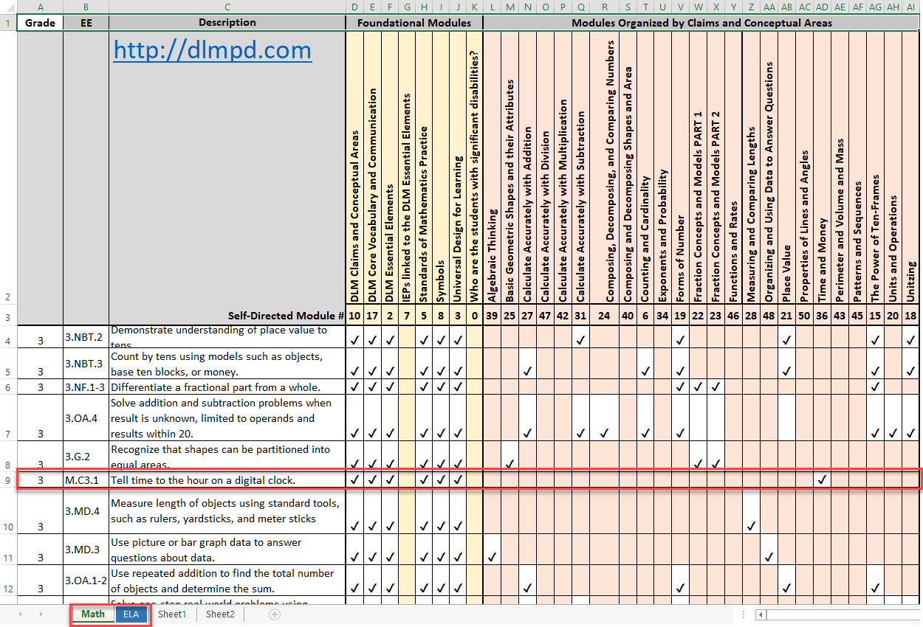

The Relationship Between English Language Arts and Mathematics Essential Elements, Nodes, and Mini-Maps
Understanding the DLM alternate assessment involves understanding the relationships among the components of the system. These components include the DLM maps, claims, conceptual areas, EEs, nodes, and mini-maps.
Each DLM map is a large and complex representation of how students develop academic knowledge and skills. These maps highlight multiple potential pathways that students may follow to develop knowledge and skills in ELA and mathematics.
Claims organize the DLM maps so that the maps can drive the assessment system and support test administrators in setting instructional priorities at each grade level. The DLM claims are broad statements about what students are to learn and what the assessments measure.
Subareas of the claims, called conceptual areas, identify large areas of conceptually related skills in the DLM maps and connect the maps to the overall claims. Conceptual areas are organized around common cognitive processes, as presented in the diagram below.

EEs represent grade-level targets for students with the most significant cognitive disabilities. EEs are embedded in the DLM maps and are related to small clusters of nodes within the maps called mini-maps.
The following image is an example of a mathematics mini-map with nodes associated with one EE. The nodes are identified by their linkage levels. Definitions of the abbreviations are shown below the image.
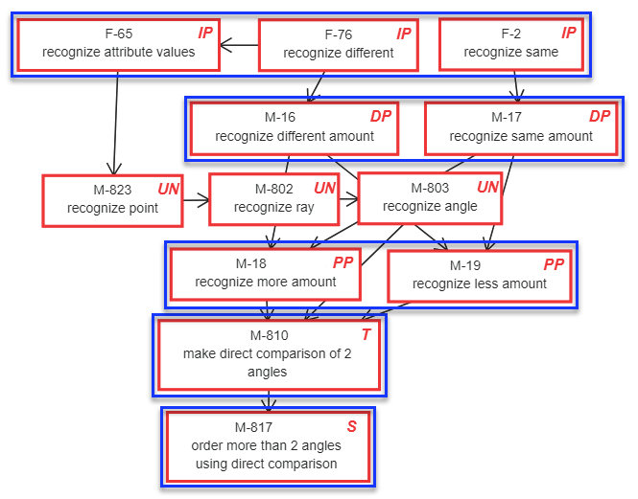
Each testlet spans a portion of the DLM map that contains nodes at one linkage level. Each linkage level contains one or more nodes related to an identified EE. Linkage levels precede, correspond to, or go beyond the expectation expressed in the EE. Linkage levels specify a student’s performance in relation to the grade-level target.
ELA and mathematics have five linkage levels.
- Initial Precursor (IP)
- Distal Precursor (DP)
- Proximal Precursor (PP)
- Target (T)
- Successor (S)
The mini-maps also have untested nodes. These untested nodes are designated with a UN. Although not tested for an EE, they are still important as part of the pathway.
Linkage levels are identified by starting with the nodes in the DLM map that most closely match the target EE. Target-level testlets are developed based on the nodes that correspond to the EE. When the target nodes are determined, multiple pathways on the map are carefully inspected to identify nodes that link directly to the target but precede or extend beyond it.
Testlets at the Initial Precursor linkage level contain nodes that represent the least complex skills. Testlets developed at this level typically reflect foundational nodes in the DLM map. These early foundational nodes connect to the target nodes through one or more pathways in the DLM map. Testlets at the Initial Precursor linkage level are typically intended for students who do not yet have symbolic communication. Test administrators administer the Initial Precursor testlets, observe the student’s behavior as directed by the testlet and then record responses in the testlet.
Testlets at the Distal Precursor and Proximal Precursor linkage levels allow students to develop the knowledge, skills, and understandings needed to reach the target. Testlets at the Successor linkage level give students the opportunity to take the next step beyond the expectations described by the EE.
HINT: A PDF with each tested EE and its associated mini-map is available for ELA and mathematics on the Educator Resource Page. These mini-maps show how students gain the knowledge and skills that help them achieve the target EE. Find the link to the Educator Resource Page for ELA and mathematics on your state page on the DLM website.

Essential Elements for Science
NOTE: Check your state’s DLM webpage to see if your state tests DLM science.
Science has three linkage levels.
- Initial
- Precursor
- Target
The DLM science EEs are the learning targets for the science assessment. The EEs are specific statements of knowledge, skills and understandings, including science and engineering practices, linked to the grade-level expectations identified in the National Research Council’s Framework for K–12 Science Education. The purpose of the EEs is to build a bridge from the general education content standards to academic expectations for students with the most significant cognitive disabilities.
Science EEs are at grade bands: elementary, middle, and high school. Each grade band’s assessment is designed to assess a specific set of EEs. The EEs included in the blueprint for each grade band are listed in blueprint documents available on your state’s page on the DLM website.

The Relationship Between the Science Blueprint, Essential Elements, and Linkage Levels
In the DLM science blueprint, the major assessed science content areas are called domains. The domains assessed across all grade bands are physical science, life science, and Earth and space science. Within each domain, three to four core ideas have been selected for use in instruction and assessment. Core ideas are the key organizing principles in science and are taught and learned over multiple grades at increasing levels of depth and sophistication. Each core idea is further narrowed into topics. EEs were developed from the content in the domains, core ideas, and topics.
EEs specify academic learning targets. In science, each EE has three linkage levels. The highest linkage level is the Target linkage level and is aligned to the content of the EE. The Initial and Precursor linkage levels are less complex than the Target linkage level and provide access to the Target linkage level at a reduced depth, breadth, and complexity. Testlets at the Initial linkage level are typically intended for students who do not yet have symbolic communication. The test administrator administers the Initial linkage level testlets and observes the student’s behavior as directed by the Educator Directions in the testlet. The test administrator then records responses for the student in Student Portal. Testlets at the Precursor linkage level allow students to develop the knowledge, skills, and understanding needed to reach the target.
Below is an example of a middle-school physical science EE with the corresponding linkage levels. Notice the reduced breadth, depth, and complexity of the expectation from level to level as well as the embedded practice, which focuses on carrying out investigations.
Essential Element: EE.MS-PS2-2
Target level: Investigate and predict the change in motion of objects based on the forces acting on those objects.
Precursor level: Investigate and identify ways to change the motion of an object (e.g., change an incline’s slope to make an object go slower, faster, farther).
Initial level: Identify ways to change the movement of an object (e.g., faster, slower, stop).
Science instructional activities are available on the Science Resource Page on the DLM website. Professional development modules for science are available under the Professional Development tab on the DLM website.

About the Kite System and Educator Portal
The Kite system was designed to deliver the next generation of large-scale assessments and was tailored to meet the needs of students with the most significant cognitive disabilities, who often have multiple disabilities. Educators and students use two of the four applications in the Kite system.
Students have accounts in Kite Student Portal.

Kite Student Portal is the customized, secure interface test administrators use to deliver the assessment to students. Students log in with their own unique user name and password, which the test administrator provides. Once Student Portal is launched, students are prevented from accessing websites or other applications during the assessment. Practice activities and released testlets are also available through Student Portal with demo user names and passwords. Educators and staff do not have accounts in Student Portal.

Staff and educators have accounts in Kite Educator Portal (EP).

Kite Educator Portal is the administrative application in which staff and educators manage student data and retrieve reports. Users can access EP via https://educator.kiteaai.org. For information on working within EP, see the Data Management Manual or the Educator Portal User Guide on the DLM website.

How to Use the DLM Website
Additional resources for test administrators are available on the DLM website. The DLM Consortium provides resources, and state-specific resources may also be available.
To access resources for your state and role, follow these steps:
- Go to the DLM website: http://dynamiclearningmaps.org.
- Hover over the States tab to reveal a list of states.
- Select your state.
HINT: Bookmark your state page or save it to your favorites for quick access later.

Resources on the DLM Website
The following table lists DLM resources designed for test administrators. These resources are available on most state webpages.
Resource | Purpose
Test Administration Manual (PDF) | Supports test administrators in preparing themselves and students for assessment
Educator Portal User Guide (PDF) | Supports test administrators in navigating EP to access assessment information, including student data and reports
Accessibility Manual (PDF) | Provides guidance to state leaders, districts, educators, and IEP teams on the selection and use of accessibility supports available in Student Portal
Educator Resource Page (webpage) | Includes additional resources for educators and test administrators, such as tested EEs and their associated mini-maps
Guide to DLM Required Test Administrator Training (PDF) | Helps test administrators access the DLM Required Test Administrator Training on the DLM Moodle training website. Training modules are located in Moodle (http://training.dynamiclearningmaps.org/).
Guide to Practice Activities & Released Testlets (PDF) | Supports the test administrator in accessing practice activities in Student Portal using student demo accounts
Test Updates Page (webpage) | Provides breaking news on test administration activities. Sign up to receive alerts when new resources become available.  http://dynamiclearningmaps.org/test-updates

How The Assessment System Works
Overview 26
Testlets 27
Required ELA and Mathematics Instructionally Embedded Assessments 27
Science Testlets during the Instructionally Embedded Assessments 28
Spring Assessments 28
Duration of the Assessment Administration 30
Field Test Testlets 30

Overview
The Dynamic Learning Maps® (DLM®) alternate assessment is designed to help plan and track a student’s learning throughout the year. Each testlet can be embedded within instruction. In this way, assessment informs teaching and benefits students.
Two general assessment windows are available. Instructionally embedded assessments occur during the instructionally embedded assessment window in the fall and winter months. During the spring assessment window, all students are reassessed on several Essential Elements (EEs) over which they were taught and assessed earlier in the year. Results used for operational purposes are based on all of the operational assessments the student took during the year, including both instructionally embedded assessment and spring assessment.

Testlets
Kite Student Portal delivers the DLM alternate assessment in testlets. Each testlet bundles together an engagement activity at the beginning of the testlet with three to nine items. Each testlet in ELA, mathematics, and science covers only one EE, except for writing testlets. Writing testlets assess a combination of two to five writing EEs in a single writing testlet. For more information about the contents of testlets, see the sections Computer-Delivered Testlets on page 47 and Teacher-Administered Testlets on page 58 in this manual. See the section Writing Testletson page 65 of this manual for more information about writing testlets.

Required ELA and Mathematics Instructionally Embedded Assessments
Instructionally embedded assessments are required in ELA and mathematics during the instructionally embedded assessment window in the fall and winter months. After the test administrator provides instruction on an EE, students take the required assessments. EEs available for assessment are in the current blueprints. Within the blueprints options and the requirements for conceptual-area coverage, test administrators decide which EEs to teach. The Essential Elements selected are to be be based on the student’s learning targets and grade level. Although this decision is typically a local decision, some states provide specific guidance on which EEs to teach and on which to test during the instructionally embedded assessment window. Some states provide additional state-specific requirements. Check with your assessment coordinator.
Progress-monitoring Excel workbooks are provide on the Educator Resource Page. Teachers may use these workbooks to record the ELA and mathematics Essential Elements chosen for instruction for a student. EEs are organized by grade and conceptual area. Simply record the EEs chosen for student instruction.
During the instructionally embedded assessment window, the test administrator can assess a student at least once on each EE that was chosen and recorded in the Instructional Tools Interface (ITI), covering at least the minimum blueprint requirements.
NOTE: Some states have additional requirements. Check with your assessment coordinator about requirements for your state. (Supporting procedures for Educator Portal are in the Educator Portal User Guide, in the section called Use the Instructional Tools Interface.)
The Kite system recommends a linkage level for the first testlet based on the First Contact (FC) survey. However, test administrators may override the recommendation and make their own choice. For the second and subsequent testlets, the system also recommends a linkage level. The test administrator can also choose a different linkage level than what the system recommends.
Results from these testlets administered during the instructionally embedded assessment window are reported in the Student Progress Reports. Test administrators can monitor the coverage of the blueprint in the Blueprint Coverage Report. These reports are not used during the spring assessment window. However, the DLM Test Administration Monitoring extract can be used during both windows. Instructions on how to access and use these reports and extracts are in the Educator Portal User Guide, Access Reports and Extracts.

Science Testlets during the Instructionally Embedded Assessments
During the instructionally embedded assessment window, science assessments are available, but they are optional and do not contribute to the end-of-year Individual Student Score Reports. Test administrators may select the science Essential Elements for instruction, create instructional plans, provide instruction, and then test the students. The system recommends a linkage level, which the test administrator may accept or may override by choosing a different linkage level. Results from these testlets are reported in the Student Progress Reports, but not in the Blueprint Coverage report since coverage of the science blueprint is not required at this time. Step-by-step instructions are in the Educator Portal User Guide in the section, “Using the Instruction Tools Interface.”

Spring Assessments
During the spring assessment window, the Kite system assigns each student five testlets in ELA and five in mathematics. If your state administers DLM science assessments, the system assigns nine science testlets to students in the state-designated grades within each grade band. In states administering biology end-of-instruction assessments in high school, the students will a biology assessment for a total of ten testlets. Each testlet includes items from one Essential Element on the test blueprint
The spring testlets are delivered separately one at a time in each subject, as they were during the instructionally embedded assessment window.
Assuming a student has completed enough instructionally embedded ELA and mathematics assessments to meet the minimum blueprint requirements for the grade and subject, all testlets assigned during the spring assessment window will come from the pool of EEs originally chosen by the test administrator.
However, sometimes a student begins the spring assessment without having met the minimum ELA and mathematics blueprint requirements during the instructionally embedded assessment window (e.g., a student moves into a district late in the year). If a student has met only a portion of the ELA and mathematics minimum blueprint requirements when the spring assessment window opens, the system assigns previously tested EEs whenever possible and randomly selects EEs in areas in which minimum blueprint requirements were not met.
If a student has met none of the ELA and mathematics requirements during the instructionally embedded assessment window, the Kite system randomly selects an EE from each part of the blueprint when the spring assessment window opens. This process continues until the student receives five testlets in ELA and five in mathematics.
During the spring assessment window, the Kite system determines the linkage level for each testlet, and the test administrator cannot override the assignment. For students who completed testlets during the instructionally embedded assessment window, the linkage level of their first ELA or mathematics testlet in the spring depends on their performance on the most recent testlets submitted during the instructionally embedded assessment window. The spring assessment testlets may be at the same linkage level as before or may be at a different linkage level. For students who did not complete any ELA or mathematics testlets during the instructionally embedded assessment window, the linkage level for their first ELA and mathematics testlets during the spring assessment window is based on the FC survey data.
For states participating in the DLM science assessment, students will receive nine testlets, one at a time, during the spring assessment window. Students will receive nine or ten testlets. Each testlet includes items from one EE on the test blueprint. The linkage level of a student’s first science testlet is based solely on the FC survey data. Only the required science testlets taken during the spring assessment window are used to calculate a student’s Individual Student Score Reports.
Whether the linkage level of the first testlet is assigned according to prior performance (for ELA and mathematics) or according to the FC survey (for science), all remaining spring assessment testlets follow the spring adaptive delivery. This means that after the first testlet is assigned in the spring, each subsequent testlet is assigned based on student performance in the prior testlets. This process continues until a student receives five testlets in ELA and five in mathematics and for science states, nine or ten testlets in science.
Each state determines its own spring assessment window, and some districts choose a shorter window within their state window. Test administrators determine when to schedule each testlet with their students. Consult with your district assessment coordinator for the dates of your state’s spring assessment window.
HINT: Complete and submit the FC survey before the opening of the instructionally embedded assessment window. If it was not submitted before then, delivery of the first testlet takes 24 hours after a student’s FC survey is submitted. Subsequent testlets are delivered in about 15 minutes after completion of the preceding testlet.
The test administrator determines when to schedule each testlet. For more details, see Frequency of Testlet Delivery During Spring Assessment on page 89 of this manual.

Duration of the Assessment Administration
The duration of the instructionally embedded assessment in minutes per testlet are as follows:
Instructionally Embedded Assessment Times Total Duration per Testlet in Minutes
Subject | Average Duration in Minutes per Testlet
ELA Reading | 10–15
ELA Writing | 10–15
Mathematics | 5–10
Science | 5–15
Duration per testlet may vary depending on each student’s unique needs. Total time for the instructionally embedded assessment varies depending on the number of EEs and linkage levels a test administrator chooses for assessment. Testlets are taken one at a time in each subject area. The test administrator can administer the testlets over multiple assessment sessions as long as all testlets are completed within the instructionally embedded assessment window.
Spring Assessment Total Duration per Subject
Subject | Average Overall Duration in Minutes
ELA | 50–75
Mathematics | 25–50
Science | 45–135
In the spring assessment window, testlets are also taken one at a time in each subject area. The test administrator can administer the testlets in multiple assessment sessions as long as all testlets are completed within the spring assessment window.

Field Test Testlets
During the optional instructionally embedded assessment window a student may receive an embedded field test testlet. During the spring assessment window, after students complete all the required operational testlets in their grade band, a student may receive one field test testlet.

Before Beginning Assessments
Key Steps 31
Complete the Security Agreement 33
Complete Training and Professional Development 34
Required Test Administrator Training 35
Professional Development for Instructional Support 36
Supplemental Training 36
Evaluate and Choose Accessibility Supports in the Personal Needs and Preferences Profile 37
Review Student Demographic Information 37
Complete or Update First Contact Survey Settings 38
First Contact Survey Drives First Testlet 38
Prepare for Assessment With Practice Activities and Released Testlets 39
Released Testlets 39
Practice Activities Access 40
Teacher Practice Activity 40
Student Practice Activity 41
Student Accounts for Practice Activities and Released Testlets 41
Troubleshoot Access in Educator Portal 43
No Test Management Access 43
No Student Testlets 44

Key Steps
Test administrators are to prepare for the Dynamic Learning Maps® (DLM®) alternate assessments by completing the steps below. Gray-shaded steps are described in more detail in this section of this manual. Other steps are defined in the other DLM resources listed in the Checklists for Test Administrators on page 9 of this manual.
Steps
- Confirm student eligibility to participate in the DLM alternate assessment.
- Share information about the DLM alternate assessment with parents or guardians, preparing them for their student’s assessment experience.
- Read this Test Administration Manual.
- Use the resources on your state’s DLM webpage to become familiar with the DLM Consortium, the assessed content, and the procedures to prepare for the assessment.
- Gain access to Educator Portal (EP).
- Complete the security agreement in your EP profile.
- Complete the Required Test Administrator Training.
- Review state-specific guidelines on required and recommended professional development modules. Complete as needed.
- Use the Accessibility Manual and work with IEP teams to determine which accessibility supports must be provided for each student taking the DLM alternate assessment. Record the chosen supports in each student’s Personal Needs and Preferences (PNP) Profile in EP.
- Review state-specific requirements for documenting DLM accessibility supports. Adjust supports in students’ IEPs as necessary.
- Review student demographic information in EP for accuracy and correct if needed.
- Ensure all student data are correct.
- Ensure all roster data are correct.
- Ensure each student’s PNP Profile is updated and complete.
- Ensure each student’s First Contact (FC) survey is updated and complete.
- Ensure that Kite Student Portal is installed on student assessment devices. See your technology personnel for help.
- Become familiar with DLM released testlets and practice activities.
- Access practice activities and released testlets using student demo accounts.
- Check compatibility of students’ devices with Student Portal by allowing students ample time with practice activities and released testlets.

Complete the Security Agreement
Test administrators are expected to deliver the DLM alternate assessment with integrity and to maintain the security of testlets. Each year, test administrators must renew the DLM security agreement through EP. The agreement expires during the first week of August every year. For a step-by-step procedure, see the Complete Security Agreement section in the Educator Portal User Guide. See the text of the Security Agreement below.
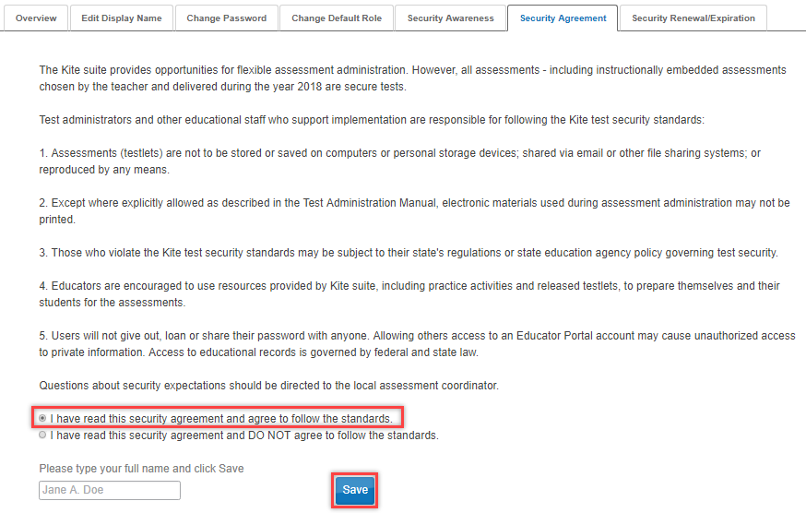
NOTE: If DLM staff discover that a user’s account has been accessed by someone other than the account owner, the user account will be considered compromised and will be locked until the state assessment administrator requests the account be opened again.
Test administrators must read, agree to, and sign the security agreement annually. Test administrators who do not complete both this process and the Required Test Administrator Training will not have access to information in the Test Management section of EP and will not be able to deliver any testlets to their students.
NOTE: See your assessment coordinator for additional guidance on test security in your state and district and for procedures for reporting assessment irregularities.

Complete Training and Professional Development
This section provides a brief overview of DLM training and professional development. See the Guide to DLM Required Test Administrator Training on the DLM website for complete information.
The DLM Consortium provides required training for test administrators, professional development for instructional support, and supplemental training. The following chart compares these three categories.
Required Test Administrator Training | Professional Development for Instruction | Supplemental Training
- Critical content for managing and delivering the DLM alternate assessment is covered.  - Test administrators will not be able to deliver testlets until training is completed.  - States decide which format(s) to offer for new test administrator training: self-directed or facilitated. All returning test administrator training is self-directed.  - Successful completion is a score of 80% or higher on the post-test. | - The modules address topics to support academic instruction for students who take the DLM alternate assessment.  - The modules are strongly recommended.  - States and districts may recommend or require specific modules.  - States decide which format(s) to offer: self-directed or facilitated. | - The training includes a variety of topics to supplement use of the DLM materials and system navigation.  - Supplemental training is strongly recommended.

NOTE: See your district assessment coordinator for a training plan tailored to your state and for training beyond that provided by the DLM Alternate Assessment® (DLM®) Consortium.

Required Test Administrator Training
Training is required for anyone who will administer the DLM alternate assessment. New test administrators must successfully complete four modules with a passing score on each module’s post-test before administering the DLM alternate assessment. In states offering science, additional science content is included in the four modules. Total training time is approximately 2.5 hours.
State policy determines who takes required training courses, which courses to offer, and the format of the courses. In some states, other staff, such as building assessment coordinators, must take the required training. The first year a state administers the DLM alternate assessment, all new test administrators must take the Required Test Administrator Training course for new test administrators. During subsequent years, the state decides whether to require returning test administrators to complete the new training course or the returning training course. In states offering the returning training course, a returning test administrator is identified from EP records. If you are a returning test administrator from 2017–2018 and mistakenly placed in the course for new test administrators, contact the local or state education agency. If a test administrator administered the DLM alternate assessment in the past but not in the preceding year, that test administrator will be placed in the new test administrator training again.
HINT: See the Guide to DLM Required Test Administrator Training located on the DLM website for complete information.
The training modules must be completed in order. Therefore, when first entering the course, only Part 1 is initially available. Each additional module becomes available after the previous module is successfully completed. Training for new test administrators includes four modules:
- Overview of the Dynamic Learning Maps Alternate Assessment
- Understanding and Delivering Testlets in the DLM Alternate Assessments
- Test Administration and Scoring
- Preparing to Administer the Assessment
Returning test administrators must successfully complete one module with a passing score on the post-test before administering student assessments. Training time is estimated at approximately one hour. If the test administrator does not successfully complete the module on the first attempt, additional training will be required. The additional training may take 30 minutes to 2.5 hours more, depending on the areas in which the test administrator was not successful on the first attempt.
States may make the required training for new test administrators available in a self-directed or facilitated format or both. Training for returning test administrators is available only in self-directed format. Regardless of training format, all post-tests for required training must be completed in Moodle. When all modules are successfully completed, test administrators are advised to print and save their certificate of completion as it may be useful in the future.
More information about the contents of each module, training formats, and procedures for completing required training is provided in the Guide to DLM Required Test Administrator Training, located on the DLM website.

Professional Development for Instructional Support
- Professional development for instruction is strongly encouraged. Modules focusing on teaching and learning in the areas of English language arts, mathematics and science, while also providing important information regarding components of the Dynamic Learning Map® system are available. If wishing to incorporate professional development modules into a training plan, the DLM Consortium offers a variety of content and multiple methods to access the materials.
- Each online, self-directed module lasts approximately 30–45 minutes and focuses on a single topic related to instruction of students with the most significant cognitive disabilities. Post-tests accompany the modules.
- Facilitated modules for groups cover the same content as self-directed modules and provide materials to support a facilitator in addressing a group of test administrators.
- Virtual Community of Practice is provided to encourage collaboration among educators across the consortium at http://dlmpd.com/clds/forum.
- For states administering science, three professional development modules specific to science content are available and more are under development. In addition, modules related to crosscutting concepts in English language arts and mathematics content standards will assist test administrators and other educators in providing science instruction. These modules provide information and strategies to help educators instruct students.
Most educators are required to participate in regular, ongoing professional development. Some states give continuing education credits for the DLM professional development modules. Print the certificate emailed to you upon completion of any module to provide documentation to your assessment coordinator to receive possible continuing education credits. The professional development website is http://dlmpd.com/.

Supplemental Training
Supplemental training and materials include short helplet videos on common EP procedures and best practices for test administrators on the Educator Resource Videos page on the DLM website (e.g., Getting Started in Educator Portal and View Test Tickets and TIPs).

Evaluate and Choose Accessibility Supports in the Personal Needs and Preferences Profile
The DLM alternate assessment offers a variety of accessibility supports. The Accessibility Manual describes a six-step process for evaluating and choosing appropriate supports for each student.
Most states provide guidelines that their IEP teams are required to use when making decisions about accessibility supports for a student during testing. Some states provide their state-specific guidelines on their DLM website as an appendix in the Accessibility Manual. Accessibility supports in the student’s PNP Profile in EP include those required to meet the student’s needs in their IEP and other supports for which a student may show a preference but are not required in the IEP. The selected supports then become available during testing. Test administrators are to review accessibility supports with the IEP team at least once per year.
The test administrator may adjust the PNP Profile between testlets in an effort to provide more appropriate supports if the initial PNP Profile selections do not allow the student to fully access the content of the testlets. To change support setting during testing, see this section in the Accessibility Manual, Changing PNP Profile Settings During Testing. The assessment coordinator can provide further IEP guidance if needed.
Procedures for choosing and saving the PNP Profile supports in Educator Portal are in the section Complete the Personal Needs and Preferences Profile in the Educator Portal User Guide.

Review Student Demographic Information
Test administrators must have an accurate list of students for whom they are responsible. Before each assessment window, test administrators must review the student names that appear on their rosters in EP. Questions to ask include the following:
- Do all eligible students appear on my list of students?
- Are any students on my list who are not assigned to me or not eligible for the DLM alternate assessment?
- Is each student assigned to the correct grade level?
- Does each student have a roster record for the correct DLM subjects assessed in the state?
- Are there any typos or misspellings?
If any errors are discovered, ask your assessment coordinator to make the corrections. Some of this student information will appear on the student’s Individual Student Score Report (e.g., the student’s name and grade). Having the information presented correctly will be important to the students and their parents or guardians.
Detailed procedures for checking this information are in the Manage Student Data section of the Educator Portal User Guide.
HINT: The correct grade and subject must be provided for the system to deliver the appropriate testlets.
Check with your assessment coordinator for specific guidance on the deadlines to review student demographic information and the procedures for correcting records.

Complete or Update First Contact Survey Settings
The FC survey gathers detailed information about learner characteristics that goes beyond basic demographics. The survey covers a variety of areas, including communication, academic skills, and attention. Test administrators must complete all required questions because the system assigns each student to a specific testlet linkage level for the first testlet in a subject based on responses to these questions in addition to other information about the student (e.g., student grade). The procedure for completing the FC survey is in the Complete the FC Survey section of the Educator Portal User Guide. A complete list of FC survey questions is included in the appendix of this manual.
The following sections of the FC survey provide an optimal match between student and testlet during the initial DLM assessment experience:
- Expressive communication
- Reading skills
- Mathematics skills
- Writing skills
- Science skills (for states testing DLM science)
The FC survey must be completed, reviewed, and submitted at least once before the first assessment each year. If the test administrator does not submit the FC survey before the instructionally embedded assessment window opens, delivery of the first testlet will occur 24 hours after submitting the FC survey. Only users with the EP role of District Test Coordinator, Building Test Coordinator, or Teacher can complete the FC survey. Review and update FC survey information as needed before the instructionally embedded assessment window. Test administrators can edit responses in the FC survey at any time a student experiences dramatic changes in expressive communication capacity. However, if testing has already begun, the change in the FC survey will not influence the linkage level of the next testlet assigned since a student’s performance on the previous testlet determines the linkage level of the next testlet being delivered. Check with your assessment coordinator for additional guidance on deadlines for reviewing and updating FC survey responses.

First Contact Survey Drives First Testlet
To begin the instructionally embedded assessment, the Kite system uses FC survey data to recommend a linkage level for the student. The test administrator may override the system recommendation and choose a more appropriate level for the student. The test administrator may also change the linkage level of subsequent testlets during the instructionally embedded assessment window. However, the system determines the linkage level during the spring assessment, and the test administrator cannot override it.
Information about how to fill out the First Contact survey is found in the First Contact Survey section of the Educator Portal User Guide.

Prepare for Assessment With Practice Activities and Released Testlets
The DLM Consortium provides two practice activities and many released testlets to support educators and students preparing for the assessment. (See the GLOSSARY on page 103 for the definition of released testlets.)
- Practice activities are designed to familiarize users with the way testlets look in Student Portal. One practice activity is for test administrators, and the other is for students.
- Released testlets are similar in content and format to real DLM testlets.
Access practice activities and released testlets through Student Portal in the practice section. Use login information provided in this manual to complete both types of activities as many times as desired.
HINT: Some released testlets are available in PDF format on the DLM website. Student Portal does not have to be installed on a computer to view these items.
If you have questions or technical problems with the practice activities or released testlets, contact your assessment coordinator or local technology personnel.

Released Testlets
Released testlets are similar to real testlets. They are selected from a variety of EEs and linkage levels from grade 3 through high school. Remember that testlets contain items that align to EEs at designated linkage levels. New released testlets are added periodically.
Testlets administered by test administrators are typically at the lowest linkage level. Test administrators also administer all writing testlets. Computer-delivered testlets are typically at the other linkage levels.
In Student Portal, released testlets are identified by subject, EE, and linkage level.
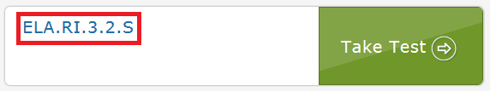
In the above image, the labels are:
Subject | Grade | Section & Level Code | Linkage Level
ELA.RI (reading instructional) | 3. | 2. (Identify details in a text) | S (Successor)
To view the EEs, linkage levels, and nodes used in ELA and mathematics assessments, look for the Educator Resource Page, which is listed under Resources for Educators and District Staff on your DLM state page. The science EEs and linkage levels are on the Science Resources page, which is listed under Resources for Educators and District Staff on your DLM state page.
The following sections describe the step-by-step procedure to access practice activities and released testlets.

Practice Activities Access
Access practice activities by selecting Other after logging into Student Portal with the practice account credentials.
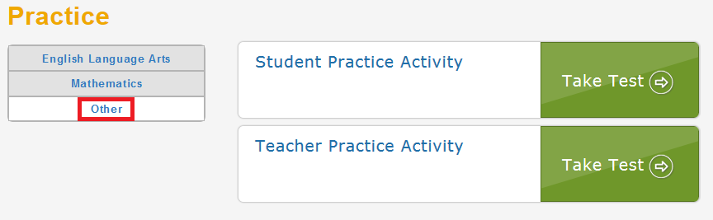

Teacher Practice Activity
The teacher practice activity is a tutorial on testlets that are administered directly by the teacher. Teacher-administered testlets are used when the student has presymbolic communication and cannot interact directly with the computer or when the content is difficult to assess on the computer (e.g., some higher linkage level mathematics testlets).
In this type of testlet, the teacher reads the instructions aloud on the testlet screens and follows them. The teacher enters the student’s responses to activities or exchanges that occur outside the system.
Most teacher-administered testlets require test administrators to gather materials to be used in the assessment. Directions for how to prepare for the testlet are provided as Educator Directions on the first screen(s) of the testlet.
HINT: Although the practice activities do not have Testlet Information Pages (TIPS), all operational testlets do have them. Information about a teacher-administered testlet, including materials needed, are listed in the (TIP) for each testlet.
Users may go forward and backward within a testlet as much as needed before submitting the responses.

Student Practice Activity
The student practice activity is a tutorial on testlets that are administered directly to a student. Computer-delivered testlets are used when the content can be assessed directly by computer and students can directly interact with the system and select their own responses, using assistive devices or other supports as needed.
Students may navigate using a mouse, Tab and Enter keys on a keyboard, or switches. If students can engage with the content but cannot advance the screens or input responses independently, teachers may navigate the screens and record student responses on their behalf. Specific allowable supports and practices to avoid are described further in Practices Not Allowed on page 79 of this manual.
Several types of items are available in student practice activities:
- multiple-choice items, in which the student selects one or more correct responses
- sorting items, in which the student selects and moves objects from one place to another. Some items require students to click the selection and the destination. Others require students to drag and drop an image. Students who use switches may need help navigating some of these screens.
- matching items, in which students identify how pairs of items are related
Students may go forward and backward within a testlet as needed before submitting responses.

Student Accounts for Practice Activities and Released Testlets
Practice activities and released testlets are available through several practice student accounts.
Each practice account has certain PNP Profile settings, as described in the Accessibility Manual. These supports are summarized in the table below.
Each practice account below is enrolled in all available ELA and mathematics practice activities and released testlets.
English Language Arts and Mathematics Practice Activity Accounts
Name | Password | PNP Profile Supports Turned On
demo.sue28 | sand3 | Spoken audio: voice source = synthetic, read at start = false, spoken preference = text and graphics, audio for directions only = false.  Contrast color: Green text on white background
demo.sue29 | wall3 | None*
demo.sue30 | swept | Switch: scan speed = 4 seconds, autoscan = manual override, autorepeat scan frequency = infinity
demo.sue31 | topic | 2x magnification
demo.sue33 | void7 | 4x magnification and invert color choice
demo.sue34 | nine7 | Color overlay (green)
demo.sue35 | jar71 | Switch: scan speed = 5 seconds, initial delay = 5 seconds, autorepeat scan frequency = 2
demo.sue36 | stop3 | Spoken audio: voice source = synthetic, read at start = false, spoken preference = NonVisual, audio for directions only = false.
demo.sue37 | after | 5x magnification
demo.lisa.25 | bank9 | N/A; Writing testlets are available with this account.
*No special settings are required for two-switch users. Use Tab to navigate and Enter to select.
NOTE: Check your state’s DLM webpage to see if your state tests DLM science.
Practice activities are also available for science.
Science Practice Activity Accounts
Name | Password | PNP Profile Supports Turned On
demo.lisa.40 | quite | None*
demo.lisa.41 | inch8 | Color overlay (green)
demo.lisa.42 | self5 | Spoken audio: voice source = synthetic, read at start = false, spoken preference = text and graphics, audio for directions only = false  Contrast color = green text on white background
demo.lisa.43 | cast9 | Spoken audio: voice source = synthetic, read at start = false, spoken preference = NonVisual, audio for directions only = false
demo.lisa.44 | toss8 | Switch: scan speed = 4 seconds, autoscan = manual override, autorepeat scan frequency = infinity
demo.lisa.45 | cusp4 | Switch: scan speed = 5 seconds, initial delay = 5 seconds, autorepeat scan frequency = 2
demo.lisa.46 | daze4 | 2x magnification
demo.lisa.47 | brave | 4x magnification and invert color choice
demo.lisa.48 | toner | 5x magnification
*No special settings are required for two-switch users. Use Tab to navigate and Enter to select.
For the supporting procedure in Student Portal, go to Access Practice Activities and Released Testlets on page 94 of this manual.

Troubleshoot Access in Educator Portal
Avoid Common Pitfalls
Save time and avoid errors by making sure you have completed these steps before beginning to assess students.

No Test Management Access
Access to the Test Managementscreen in EP is restricted until you do the following:
- Complete all Required Test Administrator Training modules with a passing score on each post-test.
- Read, agree to, and sign the security agreement in EP.
Users who have not completed each requirement will receive one of the following error messages:
- Access to Test Management is restricted due to incomplete Required Test Administrator Training. You must complete all Required Test Administrator Training before receiving access to Test Management.
- Access to Test Management is restricted because the user has not accepted and completed the annual security agreement. All previously accepted security agreements expired during the first week of August. You must read, sign, and accept this year’s security agreement in EP before receiving access to Test Management.
- Access to Test Management is restricted due to missing annual requirements. All previously accepted security agreements expired during the first week of August. You must read, sign, and accept this year’s security agreement in EP and complete all Required Test Administrator Training before receiving access to Test Management.

No Student Testlets
During the spring assessment, a student is not assigned testlets until the following steps are completed correctly:
- The student is listed on the test administrator’s roster (one roster per subject area).
- The student is rostered to the correct subjects for the DLM alternate assessment.
- The FC survey is complete and submitted.
HINT: Ensure student is assigned to the correct grade level in EP.
The assessment coordinator can help with problems for any of the above.

Introduction to DLM Testlets
Computer-Delivered Testlets 47
Overview 47
General Structure of Computer-Delivered Testlets 47
Computer-Delivered Item Types 51
Computer-Delivered Testlet Completion 54
Computer-Delivered Assessment Arrangement 57
Teacher-Administered Testlets 58
Overview 58
General Structure of Teacher-Administered Testlets 58
Teacher-Administered English Language Arts Reading Testlets 58
Teacher-Administered Mathematics Testlets 61
Teacher-Administered Science Testlets 62
Teacher-Administered Testlet Administration 63
Teacher-Administered English Language Arts Reading, Mathematics, and Science Testlet Administration 64
Writing Testlets 65
Teacher-Administered Reading Testlets 70
Teacher-Administered Mathematics Testlets 70
Teacher-Administered Science Testlets 71
Accessibility Supports 71
Testlets For Students who are Blind or have Visual Impairments 73
Form Types 73
Form Availability 74
Form Delivery 74
Tactile Graphics 75
Response Scoring 75
Alternate Forms for Students Who are Blind or have Visual Impairments 76
Teacher-Administered Alternate-Form Testlets 76
Computer-Delivered Alternate-Form Testlets 76
Administration of Alternate-Form Testlets 76
Practices Allowed 77
Breaks 77
Individualized Student Response Mode 77
Special Equipment for Positioning 77
Navigation Across Screens 77
Test Administrator Response Entry for Students 77
Interactive Whiteboards 78
Alternate Representations of Response Options 78
Graphic Organizers 78
Blank Paper 78
Use of Reinforcement 78
Generic Definitions 79
Practices Not Allowed 79

Computer-Delivered Testlets

Overview
Testlets delivered directly to students via computer are designed with the assumption that students can interact independently with a computer, using special devices (such as alternate keyboards, touch screens, or switches) as necessary. Computer-delivered testlets in the Dynamic Learning Maps® (DLM®) alternate assessment are most common at all levels but Initial Precursor, especially the upper linkage levels, where the content being assessed is appropriate for delivery through the computer. Reading, mathematics, and science assessments include computer-delivered testlets. Writing testlets are always administered by test administrators and are described in Teacher-Administered Testlets on page 58 of this manual. Some students may function at upper linkage levels but cannot interact directly with the computer due to physical limitations. In these cases, the test administrator may navigate the screen for the student and enter the student’s responses.
HINT: Screenshots in the following sections of this manual demonstrate how a testlet should appear on an assessment device. If a testlet is difficult to view on the assessment device, check the device’s display settings and the screen resolution. The screen resolution should be 1024 by 768. Also, check the student’s PNP Profile settings to ensure the most appropriate settings have been selected. After doing this, if the issues cannot be resolved, contact your technology personnel or your assessment coordinator.

General Structure of Computer-Delivered Testlets
Testlets in ELA, mathematics, and science are delivered differently based on research about effective instructional practices for students with the most significant cognitive disabilities. However, testlets in all subjects begin with an engagement activity to motivate students, activate prior knowledge, and prepare students for the cognitive process required in the items.

Computer-Delivered ELA Testlet Structure
Students taking DLM ELA testlets are assessed on both reading and writing skills. During a reading testlet, students participate in two readings of a text. The first reading serves as the engagement activity and provides students with an opportunity to build a mental representation of the entire text before responding to items. The second reading includes items embedded within the text or placed at the end of the text, as appropriate. Items are embedded within texts even when the items do not assess reading comprehension.
The first screen in ELA testlets directs students to read the text, read the text again, and then respond to items. Although some students taking computer-delivered testlets may require support to navigate from one screen to the next or to enter their responses, most students at the upper linkage levels will independently read the text and respond to the items.
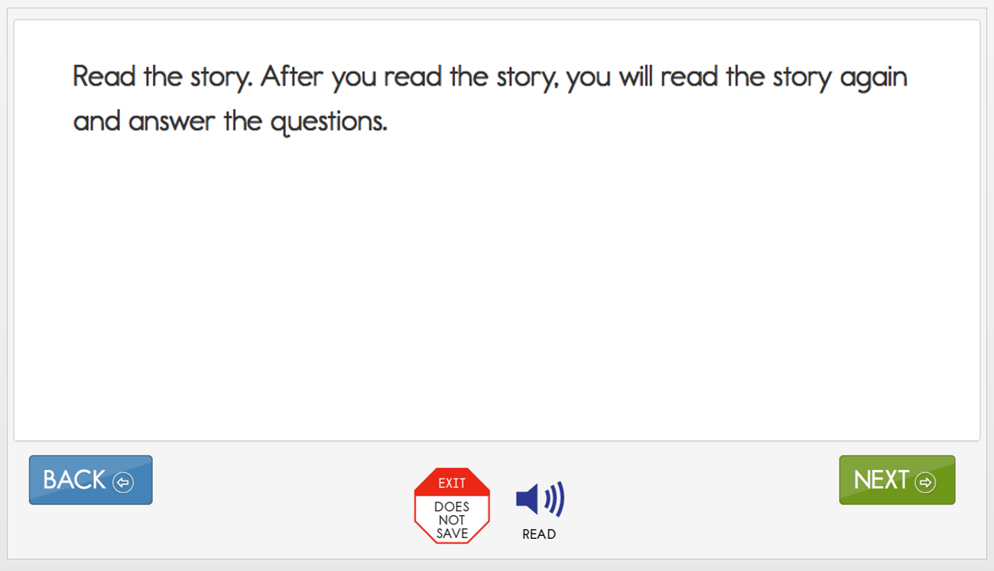
Students will then read through the text, as shown below. They may have the text read aloud by the computer if Spoken Audio is selected in the student’s PNP Profile. For all testlets, test administrators are permitted to read aloud to students.
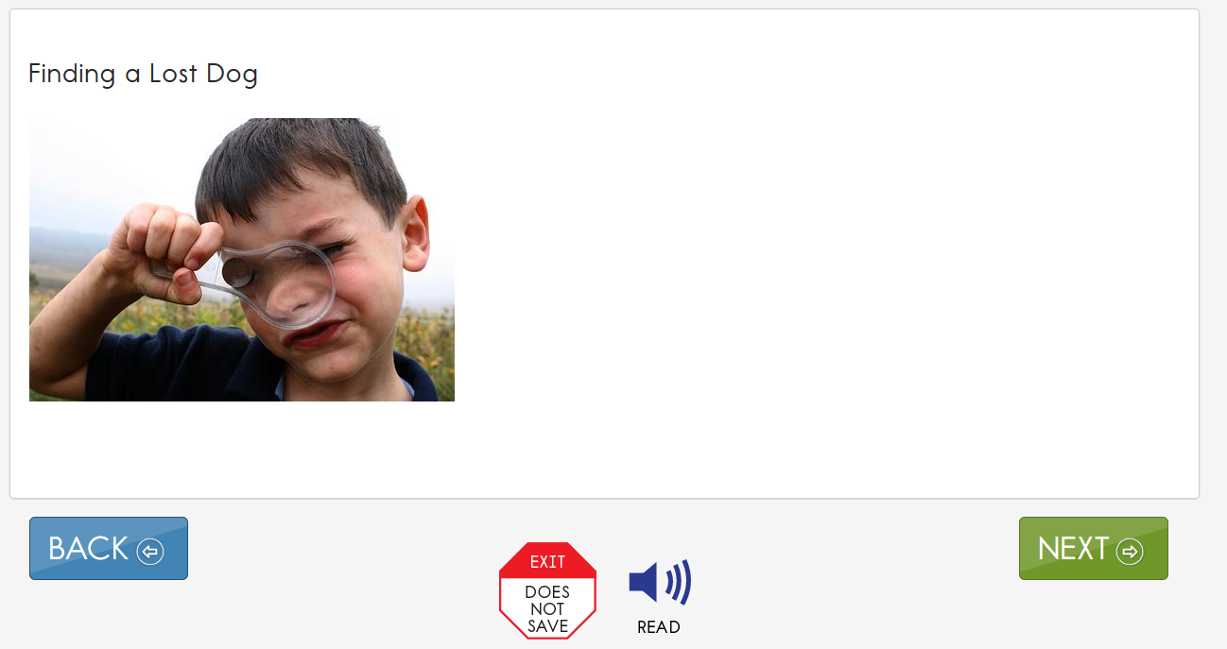

Computer-Delivered Mathematics Testlet Structure
Mathematics testlets start with an engagement activity that provides a context for the items. The engagement activity does not require a response. Mathematics testlets are built around a common scenario or activity to investigate related facets of student understanding of the targeted content as shown.
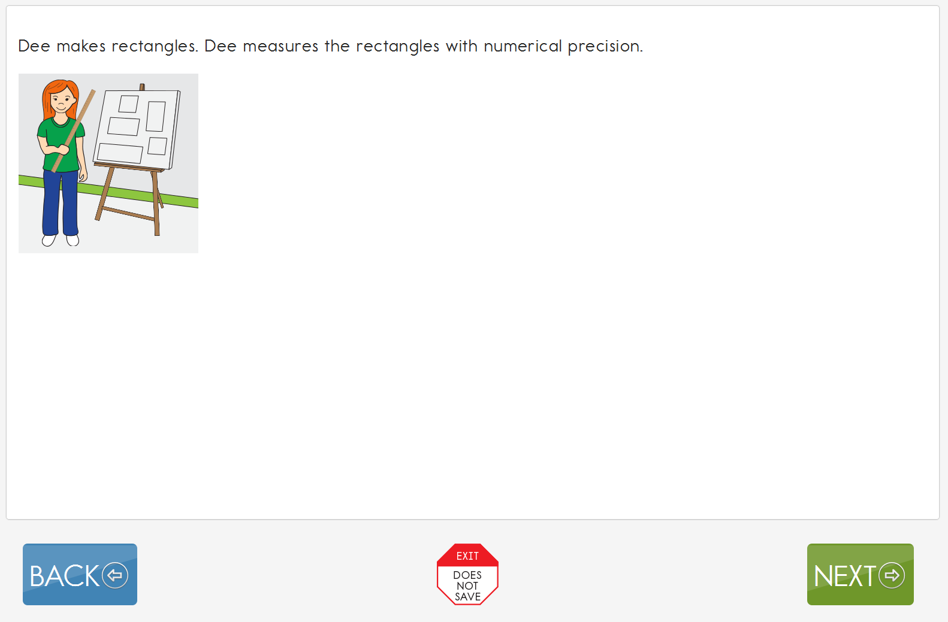

Computer-Delivered Science Testlet Structure
NOTE: Check your state’s DLM webpage to see if your state tests DLM science.
Science testlets begin with an engagement activity, just like testlets in ELA and mathematics. These engagement activities are designed to motivate students, provide a context, and activate prior knowledge. Science testlets may be designed around a science story featuring an experiment or classroom activity. The story is presented twice; items are either embedded within the second presentation or presented at the end of it. For shorter science testlets, stories may simply provide a context for the items. In this case, the science story is presented a single time, and all items appear at the conclusion of the activity.
An example of a science story is shown below. The instructions at the beginning of the testlet tells students what they will be doing in this testlet. In this science story, the student is to read the text and answer some questions.

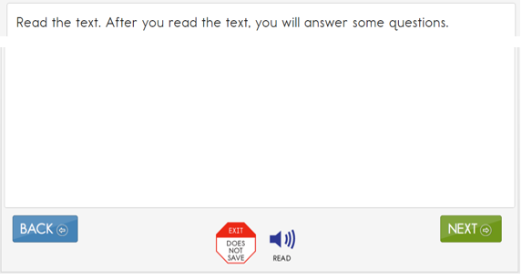
The image below is from a testlet where a short story is presented only once to the student. The items in the testlet, although not shown in this image, follow the story on the next screen of the testlet.
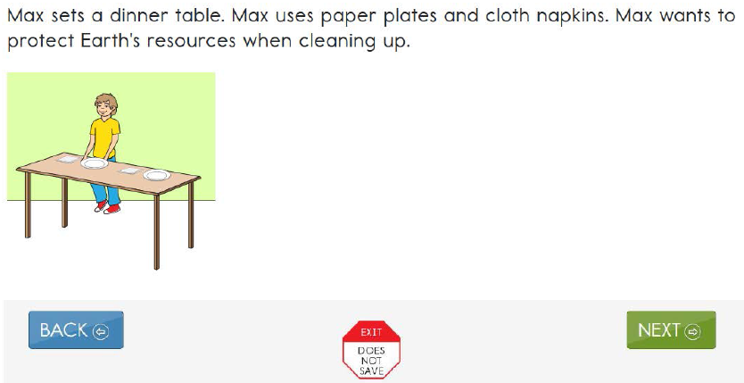

Video-Based Testlets
Some science testlets in the upper grade bands and the upper linkage levels may include a video in the engagement activity. Students will view a short (less than 30 seconds) video and will then respond to three items that include still-frame photos from the video.

Computer-Delivered Item Types
Students may encounter a variety of item types when taking computer-delivered testlets. Most testlets are designed for students to interact directly with the computer. Item types include the following:
- single-select multiple choice
- multi-select multiple choice
- matching
- sorting
- select text
In general, the DLM alternate assessment uses the most straightforward item type that allows for quality assessment of the Essential Element (EE). For this reason, complex item types are used only occasionally at upper linkage levels. The previously described practice activities include one or more examples of the above item types.
The most common type of computer-delivered item is a single-select multiple-choice item with text response choices, as shown below.
Students may also see single-select multiple-choice items with image response choices, as shown below.
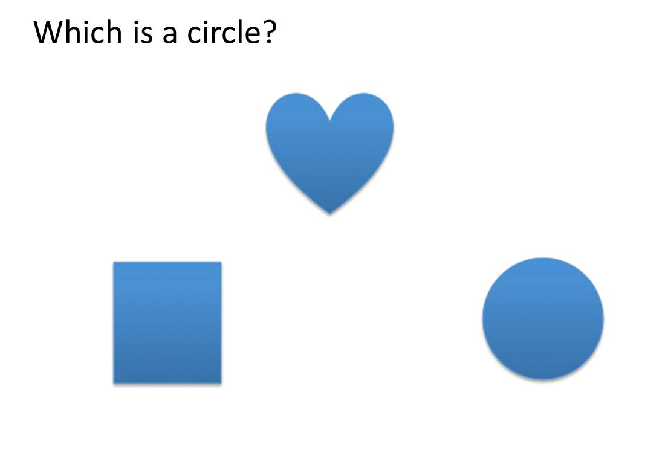
Multi-select multiple-choice items provide students with the opportunity to make more than one response choice, as shown in the following example.
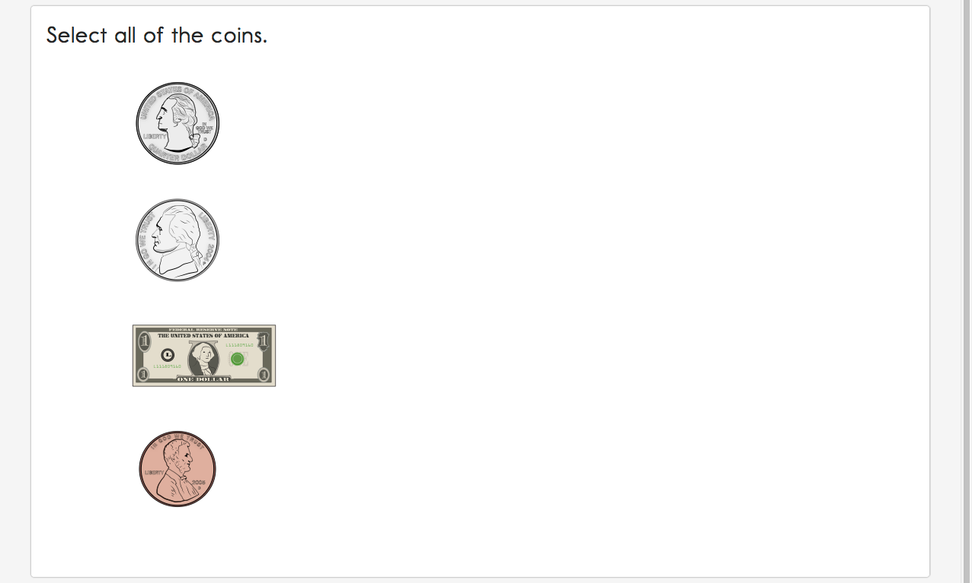
In some items, students may be asked to match responses from two lists, as in the example below.
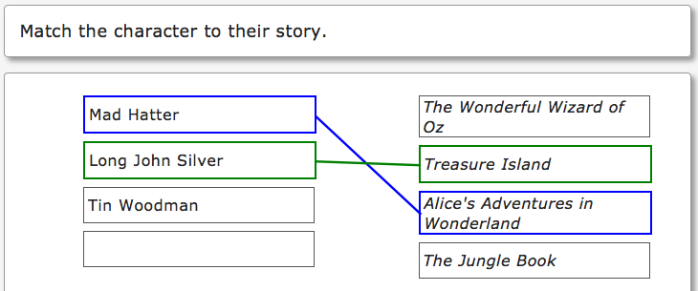
Students may also encounter items asking them to sort words or images into categories. For students who use a mouse to interact with the computer, the system uses a drag-and-drop format to sort items. In the example below, the student selects the circle and then drags it into a box on the right, either by selecting the mouse button and moving the mouse or, if taking the assessment on an iPad or interactive whiteboard, by touching the object and dragging it to the desired location. Students who are unable to use the drag-and-drop format may direct the test administrator to sort the items.
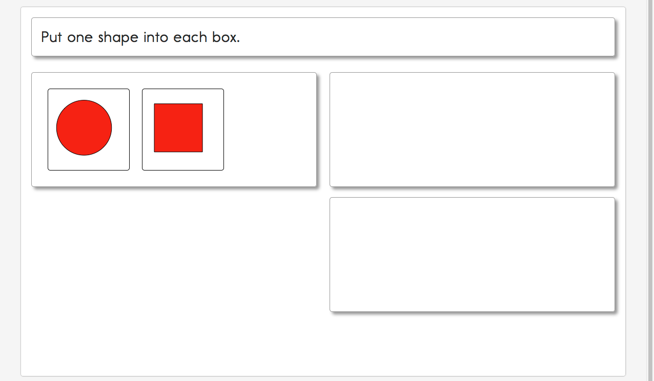
The final type of computer-delivered item that students might see is select text. Select-text items are used only in some ELA assessments. Response choices are marked with a box around the word, phrase, or sentence. After the student makes a selection, the outline around the word, phrase, or sentence becomes bold and is highlighted in transparent yellow, as shown in the example below.
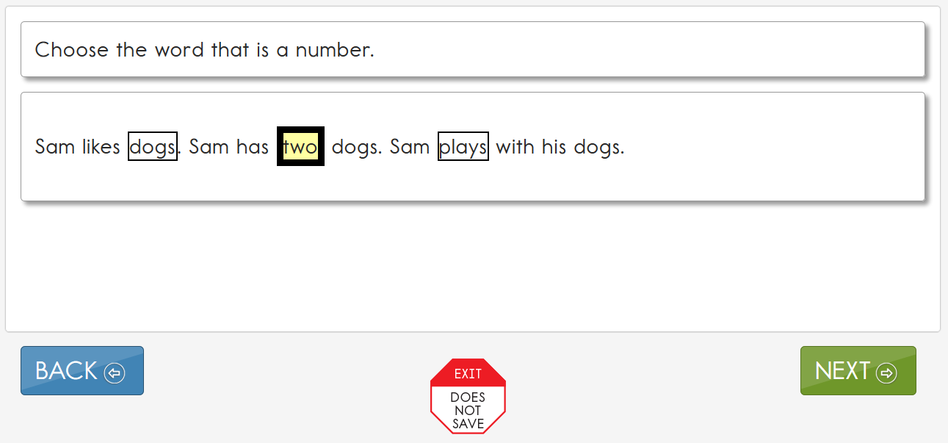

Computer-Delivered Testlet Completion
The procedures for completing computer-delivered testlets are the same for all subjects. When the student first views an item, the responses will appear as shown in the item below.
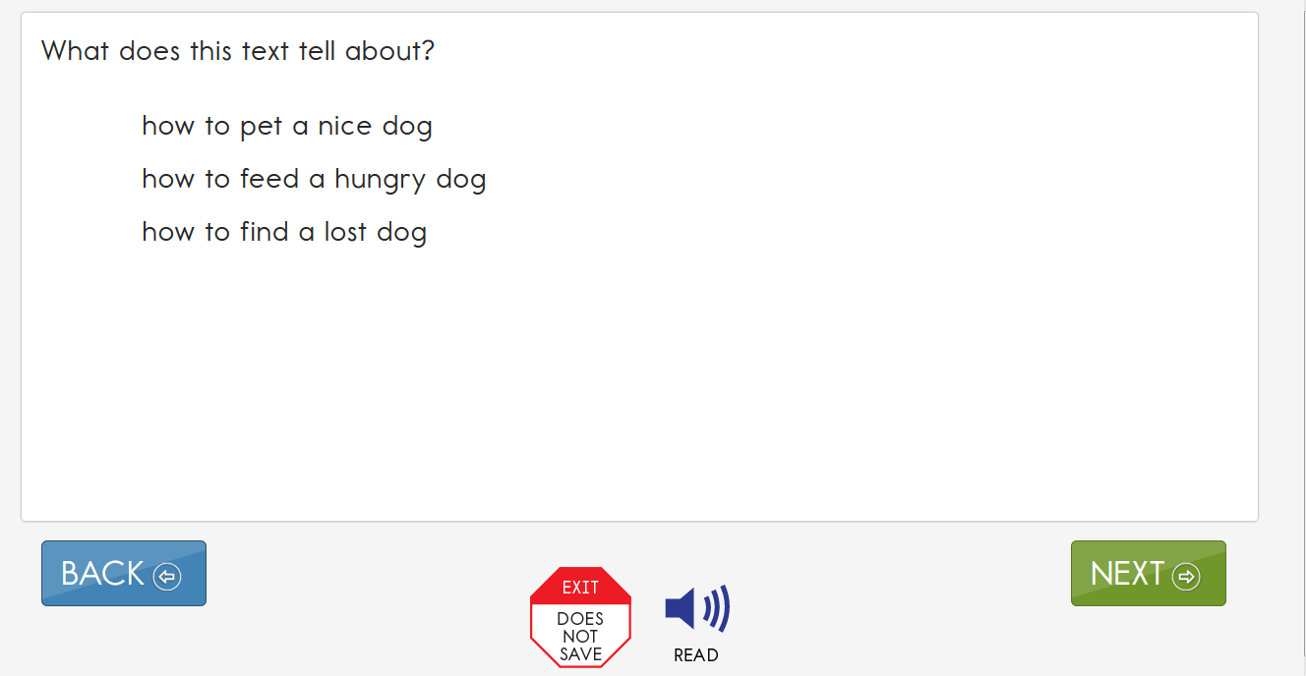
Once a student selects a response, a box appears around the response choice. The student is able to select NEXT or BACK to navigate through the testlet screens. The response choice will stay selected.
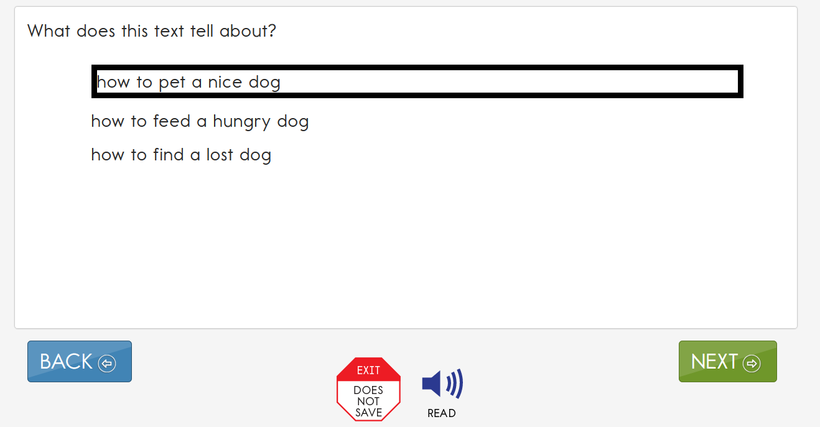
If the student wants to change a response at any time during the testlet, they may go back to the screen that displays that item and simply select another response choice.
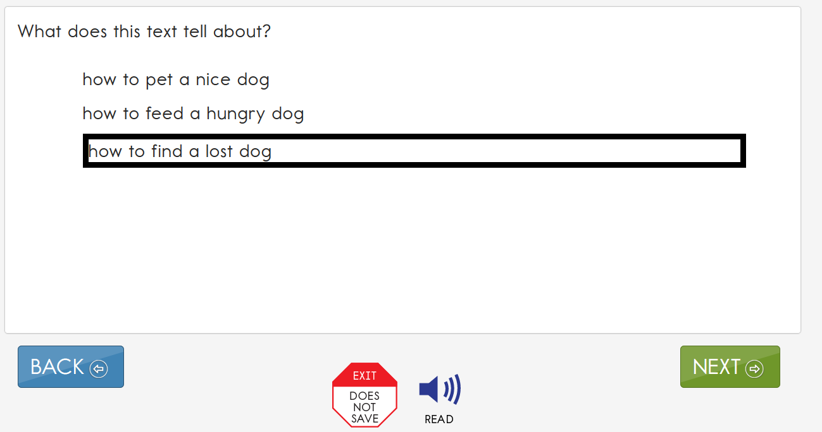

No Response Option
All testlets at the lowest linkage level and a few teacher-administered testlets at higher linkage levels include No response as a response option. However, not all testlets include No response as one of the options. If an item does not offer the No response option, and the student does not respond to the item in the testlet, the test administrator leaves the item unanswered. Whether No response is available for selection or if the item is left unanswered, the item is scored as a zero. When a student has not responded to any items in a testlet, the testlet is still to be submitted for the student. If the student is capable of producing an intentional response but does not do so (e.g., due to distractions or behavior problems), if state policy allows, the test administrator can use the EXIT DOES NOT SAVE button and begin the testlet again when the student is more engaged.

System Timeout
The DLM alternate assessment is administered individually and are not timed. Students may take as much time as needed and may work in settings that are most appropriate for them. In other words, any flexibility in location and assessment time that the student needs is permissible. For example, the student may take as many breaks as needed throughout the completion of a testlet. During the administration of a testlet, Student Portal can sit inactive for as long as 90 minutes before timing out.
After 88 minutes and 30 seconds of inactivity in the testlet, the system provides the student with this warning message.
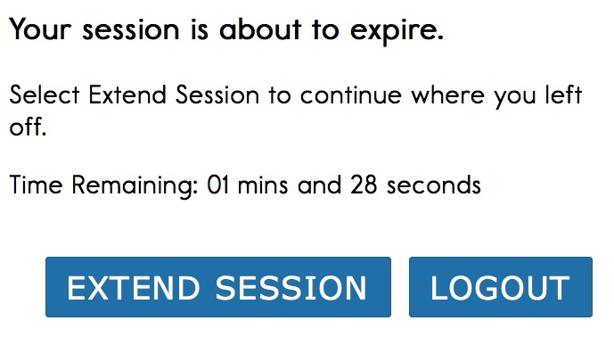
- If the student does nothing and no activity occurs before the countdown reaches 0, the system logs the student out of the testlet and returns to the login screen. The testlet status returns to Unused, and the system retains no answers.
- If the student selects Extend Session, the system disregards the idle time, closes the prompt, and returns to the screen where the student had been working.
- If the student selects Logout, the system logs the student out of the testlet and returns to the login screen. The testlet status returns to Unused, and the system retains no answers.
Students with the most significant cognitive disabilities who qualify for the DLM alternate assessment require extensive, repeated, and individualized instruction and ongoing supports that are not temporary or transient. These students often have difficulty retaining information in working memory for extended periods of time. Therefore, testlets were created to be brief: containing only a few items, each testlet begins with an engagement activity designed to activate prior knowledge, motivate the students, and provide a context. While DLM test-administration procedures are designed to be flexible and allow students to take breaks during a testlet, most students who experience an extended interruption during test administration have difficulty retaining information in working memory after the interruption. Research has shown that an extended interruption during test administration can adversely affect student performance (Sinharay et al., 2014). Thus, Student Portal was designed to time out after an extended period of inactivity without retaining the responses, allowing the student to begin the assessment afresh when ready.

Computer-Delivered Assessment Arrangement
Prior to test administration, evaluate how to arrange the computer or other assessment devices for the student and test administrator. All arrangements for computer-delivered testlets are to do two things, maximize both student interaction and student independence” for conciseness.
Assessing students in a familiar environment is helpful, but the test administrator must ensure that the student is able to concentrate without distractions from other students. Assessing students with the most significant cognitive disabilities is to be individualized and not be conducted in a group setting, as is done with standardized assessment for students who take general education assessments.

Maximize Student Interaction with the Computer-Delivered Testlet
The arrangement is to maximize student interaction with the testlet through the computer or other assessment devices based on the student’s needs. For instance, if the test administrator sits with a student, the student is to sit directly in front of the computer and the test administrator is to sit off to the side, as shown in the image.
If the test administrator sits next to a student who is able to use the mouse without assistance, the test administrator is to sit on the side of the student opposite from the mouse so the student has space to move the mouse and the test administrator is not tempted to move the mouse for the student. A student who takes the assessment on an iPad may be able to hold the iPad and respond to items independently. If not, the test administrator may hold the iPad in a position that provides maximum visibility for the student.

Maximize Student Independence
Although test administrators must monitor students at all times, the assessment arrangement is to maximize student independence and minimize test administrator involvement. For students who may need assistance during the assessment, the test administrator is to sit close to the student to monitor the assessment. On the other hand, if the student is able to work independently, the test administrator can keep more distance while making sure the student takes enough time and responds to all items.

Teacher-Administered Testlets

Overview
Some testlets (e.g., all writing testlets, all testlets at the lowest linkage level, and some mathematics testlets at higher linkage levels) are designed to be administered directly by the test administrator. The testlets are still delivered in Student Portal, but the test administrator plays a more direct role than in computer-delivered testlets. In teacher-administered testlets, the test administrator is responsible for setting up the assessment, delivering it to the student, and recording responses in the testlet in Student Portal.

General Structure of Teacher-Administered Testlets
All teacher-administered testlets have some common features.
- A Testlet Information Page (TIP) is provided with each testlet, which the teacher must review before beginning the assessment. Since the test administrator must gather the needed materials to be ready for test administration, the TIP can be reviewed several hours or even days before testing.
- The TIP may have pictures that need to be printed ahead of time (e.g., science testlets at the Initial linkage level). Best practice is to print pictures in color.
- Directions and scripted statements guide the test administrator through the administration process.
- The testlet includes an engagement activity and items.
- The test administrator enters responses for the student.

Teacher-Administered English Language Arts Reading Testlets
In teacher-administered reading testlets, items focus on the cognitive skills that precede conventional literacy. These items are not traditional reading-comprehension questions, but rather are designed to assess the skills identified in the DLM map as critical precursors to reading for meaning. These types of items are embedded in the context of a shared reading and are intended to mirror early literacy instruction. Items assess skills such as identifying familiar materials or identifying words that describe familiar people.
Shared reading strategies that an educator might use during the first reading of a text include the following:
- encouraging engagement and interaction
- discussing words
- connecting words or pictures to student background knowledge and experience
- labeling and pointing out pictures
- modeling concepts about print (reading left to right, one-to-one correspondence between a spoken and written word, etc.)
- pointing out rhymes, syllables, and sounds in words
- asking questions to further engage students
- modeling how to communicate using students’ communication methods
- using a think-aloud process to model how to decide whether to make a comment
- incorporating objects to help make connections
HINT: Pictures or words from a word bank cannot be substituted for text. See Supports: Allowed and Not Allowed in the Accessibility Manual.
Test administrators is to engage in shared reading strategies with the student during the first reading of the text in a reading testlet. During the second reading of the text, the test administrator is to refrain from using shared reading strategies and instead is to focus on administering the items that are embedded in the second reading or placed at its conclusion.

Structure of Teacher-Administered Reading Testlets
Teacher-administered reading testlets follow the same structure as computer-delivered reading testlets. First, the text is presented in its entirety. However, unlike computer-delivered testlets, the test administrator reads the text aloud using shared reading strategies to maximize student engagement. Then, the text is presented again with items either embedded within the reading or placed at its conclusion. This type of testlet is often used at the Initial Precursor level, where students do not have the skills to directly interact with the computer. Teacher-administered testlets are also used for some testlets at higher linkage levels in the lower grades when the student is working with a familiar text.
For more information about shared reading strategies, see the professional development module called Shared Reading through the Modules page on the Professional Development page of the DLM website.
Below is an example of the directions provided on the first screen in a teacher-administered reading testlet. This screen provides hints about a shared reading strategy. After this screen, the story screens begin.
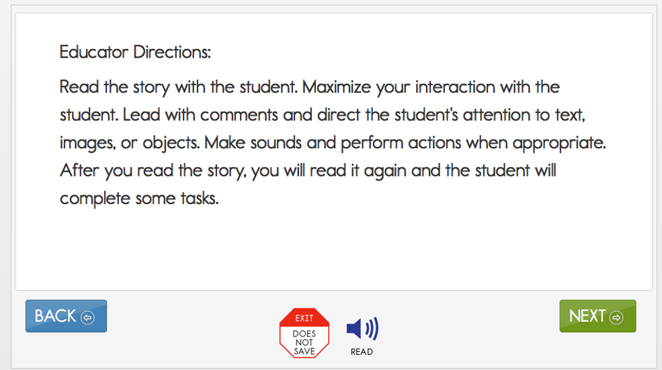
In reading testlets, Educator Directions also appear between parts of the testlet. Below is an example of a transition screen displayed after the test administrator has read a text with the student for the first time. The transition screen tells the test administrator that the first reading is over and that the second reading is about to begin. During the second reading, the student will respond to items embedded within the second reading or placed at its conclusion.
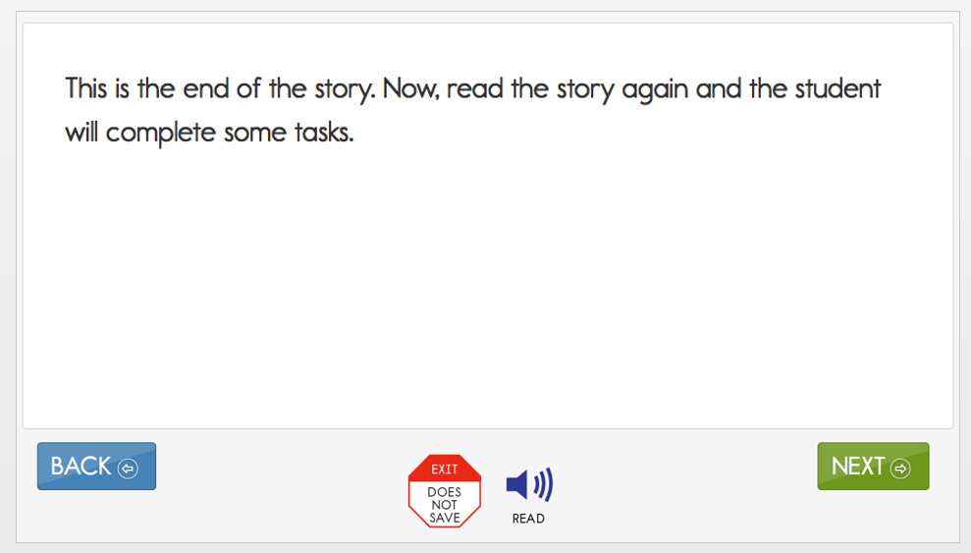

Alternate Text for Reading Testlets
When administering a testlet to a student who uses human read-aloud support and also requires verbal descriptions of images, use the alternate text available in supplemental pages of the Testlet Information Page (TIP). Each page of the TIP shows the onscreen text and images for the first and second presentations of the text. Descriptions of the images are printed below the picture and are labeled Alt Text (e.g., a picture of a dog is presented and below the picture are the words, “Alt Text: a dog”). For students who require verbal descriptions of the images, read the text on the screen, and then read the alternate text description exactly as it appears on the TIP.

Teacher-Administered Mathematics Testlets
In mathematics, the Initial Precursor level is always a teacher-administered testlet. Some higher linkage level testlets in mathematics are also teacher-administered because the tested content requires assessment outside Student Portal. An example is a procedural node that asks the student to measure volume. Recognizing three-dimensional objects and manipulating them onscreen requires keen perceptual and motor skills, neither of which are essential to the student’s cognitive understanding of how to measure volume. Test administrators directly administer these types of testlets to make them accessible for students who are blind, who have visual impairments, or who have physical disabilities that impact the student’s ability to take the testlet onscreen.

Structure of Teacher-Administered Mathematics Testlets
All teacher-administered mathematics testlets are similar in their structure. They include instructions to the test administrator called Educator Directions. An example of Educator Directions for an Initial Precursor mathematics testlet is in the image below. First, the directions tell the test administrator, in a general way, what will happen in the testlet. Then, the directions specify any materials that need to be collected. More information about the materials and recommended substitutions are on the TIP, which the test administrator must access before test administration. The test administrator may make substitutions as long as the substitutions do not change what the testlet measures and the materials are still grouped as indicated in the testlet. The last part of the directions page outlines the needed materials, which items need the materials, and in what order the item presents the materials.
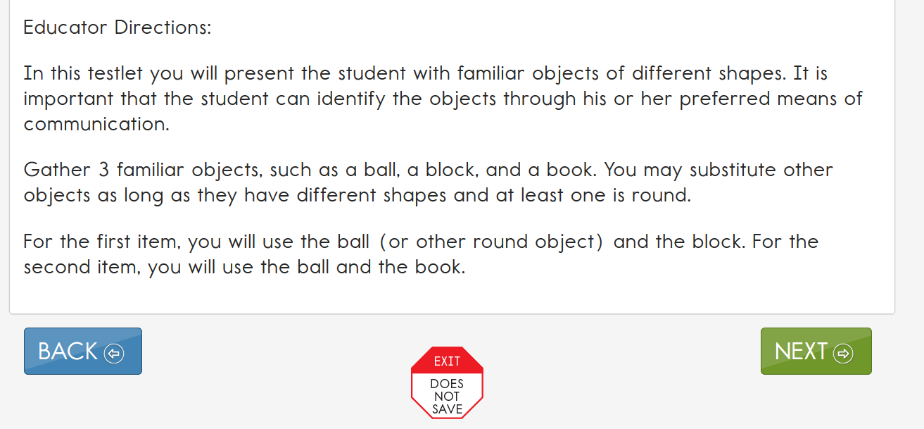
In addition, both types of teacher-administered mathematics testlets contain an engagement activity, which occurs when the test administrator presents the materials used in the testlet and engages the student in exploring the materials. An example of an engagement activity in a teacher-administered mathematics testlet is shown below.
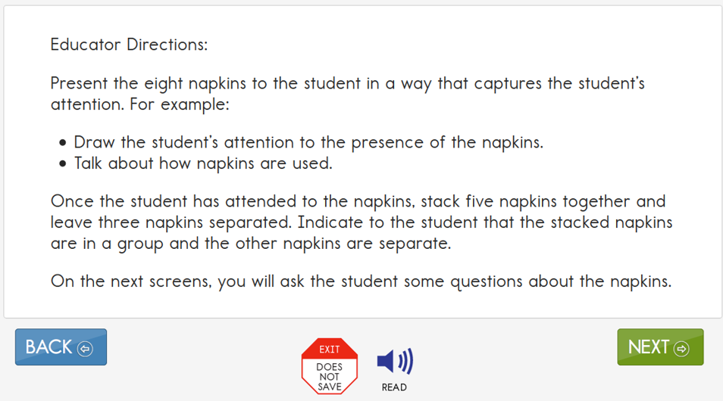

Teacher-Administered Science Testlets
NOTE: Check your state’s DLM webpage to see if your state tests DLM science.
In science, teacher-administered testlets are at the Initial linkage level. Initial linkage level science testlets are structured as a series of statements that the teacher reads to the student and are often accompanied by picture-response cards. Picture response cards must be printed from the TIP before test administration, and best practice is to print them in color. Some Initial testlets specify the use of other materials.

Structure of Teacher-Administered Science Testlets
All teacher-administered science testlets are similar in structure. Teacher-administered testlets include instructions to the test administrator called Educator Directions. An example of Educator Directions for an Initial linkage level science testlet is below. First, the directions tell the test administrator, in a general way, what will happen in the testlet. The directions will specify any materials that must be collected. More information about the materials and recommended substitutions are located on the TIP. The test administrator may substitute materials as long as the substitutions do not change what the testlet measures. The last part of the directions page outlines the needed materials, which items need the materials, and in what order the item presents the materials.
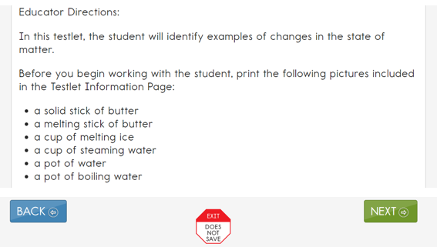
Additionally, teacher-administered science testlets contain an engagement activity, in which the test administrator presents picture response cards or materials and engages the student in exploring the materials. An example of an engagement activity in a teacher-administered science testlet is shown below.
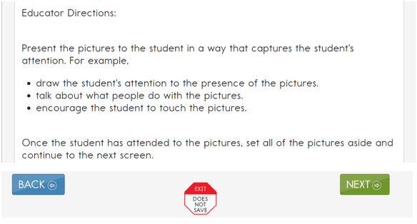

Teacher-Administered Testlet Administration
Teacher-administered testlets are standardized. Anything in quotes and bold print is to be presented verbatim to the student. There are two exceptions to this rule. The first is when the student uses sign language interpretation or language translation supports as allowable and as described in the Accessibility Manual and on the TIP. The second exception is when a substitution has been made for a particular material. The test administrator must then use the name of the substituted materials when reading the item to avoid confusing the student.

Teacher-Administered English Language Arts Reading, Mathematics, and Science Testlet Administration
The two specific instructions for presenting items or directions to students are SHOW and SAY. However, because of hearing and vision limitations, some students will not be able to see what is shown and others will not be able to hear what is said. SHOW means that an educator presents the materials to the student, using sensory modalities appropriate for that student. SAY may require nonverbal communication appropriate for the student’s sensory modalities, such as signing.
Below is an example of an item screen that may be embedded in the second reading of an ELA text. The Educator Directions tell how to interact with the student. The test administrator reads the lines presented in bold after SAY directly to the student. The administrator also performs the actions described after SHOW for the student.
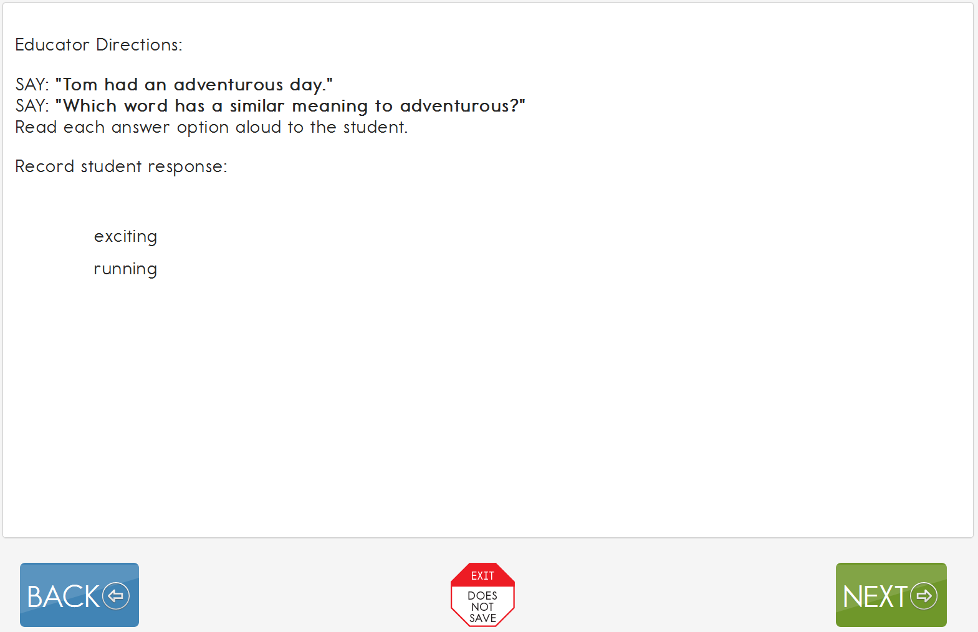
All teacher-administered items have response options that reflect possible student responses to the statement or questions in the item. The test administrator evaluates the student’s response, chooses the best description of what was observed, and records the choice in the testlet. The test administrator must be familiar with the student’s typical modes of expressive communication because any mode for communicating a response is acceptable.

Writing Testlets
All writing testlets are teacher administered and are required for every grade. Writing testlets assess a combination of two and as many as six writing EEs. Information about each writing EE is available on the Educator Resource Page under the heading Tested Essential Elements. The student works outside Student Portal and interacts with the test administrator. Only the test administrator interacts with the testlet in Student Portal.
Writing testlets are at one of two levels: emergent or conventional. The level of writing testlet the student receives is determined using prior information about the student, including FC survey responses. Emergent-level writing testlets are used for students who do not yet have or are working on early symbolic understanding. Emergent-level writing testlets are a combination of the Initial and Distal Precursor linkage levels.

- Conventional-level writing testlets are used for students who have symbolic understanding and can use writing tools to communicate:
- The testlets are named either emergent or conventional based on their level of complexity. Students, who have symbolic understanding and can use more traditional writing tools to communicate take a writing testlet that combines linkage levels at the Proximal Precursor, the Target, and the Successor linkage levels. Writing testlets at this level are called a Conventional Writing testlet because they are a little more typical of a traditional writing assessment.

- For both the emergent and conventional writing testlets, students use the orthography-based tools they use for writing in everyday instruction. Many students taking the DLM alternate assessment will need a test administrator to assist them in accessing a writing tool. The tools must offer students access to all 26 letters of the alphabet.
The DLM writing testlets assess students’ ability to communicate using writing and their mastery of the precursor skills that lead to writing. These skills focus on understanding letters and words and the expression of ideas through words. Testlet response options that refer to “writing” or “the student wrote” can include any method the student uses for writing.
The following supports are allowed for writing testlets:
- pens, pencils, markers, crayons
- whiteboards
- traditional keyboards using word-processing software
- adapted keyboards that include all 26 letters of the alphabet
- tablet computer keyboards using word-processing software
- alternate keyboard (e.g., on-screen or switch-enabled keyboard)
- alternate pencils, including alphabet flip charts
- eye-gaze displays of letters
- letter-by-letter dictation of any sort
- word-prediction software
  - Word prediction is an intelligent word-processing feature that can alleviate writing breakdowns for a range of students simply by reducing the number of keystrokes necessary for typing words. It removes motor barriers to typing to reduce the gap between generating ideas and capturing them in writing.
The following supports are not allowed for writing testlets:
- whole-word or sentence dictation
  - In order to test the full criteria of writing Essential Elements, students are not allowed to dictate whole words or sentences.
- speech-to-text software
- selection of pictures or words from a word bank

Pictures, Symbols, or Use of a Word Bank
Pictures, symbols, or words from a word bank are not allowed and may not be substituted for words in a sentence. This practice is forbidden because the meaning that an individual assigns to a picture or symbol depends upon the individual’s motivation, neurological and developmental status, sensory abilities, cognitive, communication, and language skills, and world experience (Mineo Mollica, 2003). Furthermore, the ability to learn the meaning of pictures or symbols is directly related to an individual’s understanding of the word associated with the picture or symbol. In other words, individuals who understand the meaning of the spoken word learn the associated picture or symbol rather easily while individuals who do not understand the spoken word need more time to learn the meaning of the picture or symbol (Romski & Sevcki, 1996, 2005). Because students who participate in the DLM alternate assessment have universally impaired cognitive and language skills, it is not possible to ensure that each student’s understanding of pictures and symbols introduced in the assessment will match the intended meaning.

Writing Topic
During both types of writing testlets, the test administrator and the student participate in an engagement activity related to choosing a topic about which to write. The testlet does not include preselected topics for writing assessments.
- In Emergent writing testlets, students often choose from a list of topics that they have been exposed to during instruction.
- In Conventional writing testlets, students also write about familiar topics. If able, they independently select a subject on which to write. The subject is to be an informational topic that is relevant to instruction and familiar to the student.

Test Administration Tasks in Writing Testlets
The test administrator has two types of tasks in writing testlets.
- The first type of task requires the test administrator to evaluate a process used in writing. The testlet has items that are presented to the test administrator as the student works through the tasks in the writing testlet.
- The second type of task found in most writing testlets requires the test administrator to evaluate the student’s final writing product.
For the first type of task, test administrators will perform the following tasks:
- Give the student a verbal prompt from the onscreen Educator Directions. As apparent in the image below, the verbal prompt may be “SAY: ‘You are going to write about a person, place, or object today. What would you like to write about?’”
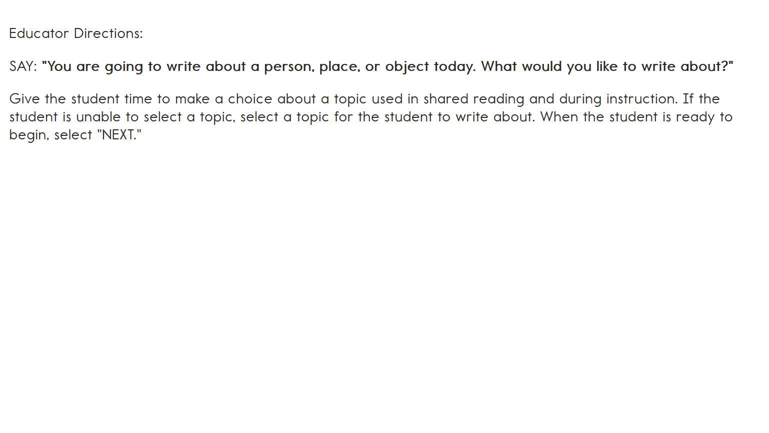
- The test administrator may present the student with a list of familiar topics that have been used during instruction, or the student may think of a topic without any prompting.
- The testlet screen prompts the test administrator to ask the student to engage in writing tasks.
  - For step 3, an example of a verbal prompt may be “SAY: ‘Write about (topic) using words that describe (topic).’”
  - The test administrator says the prompt aloud to the student, inserting the actual topic selected for the writing testlet.
- The test administrator is directed to wait and observe the student’s writing process in response to the prompt.
- The test administrator evaluates the student’s behavior according to the description in the response options. The test administrator then chooses the description that best matches the student’s writing process.
EXAMPLE: If the student’s behavior could be described by two response options, the test administrator selects the response option that represents the higher of the two options. In the image below, if the student wrote some words related to the topic and some words that were not related to the topic, the test administrator has two response options from which to select, “Wrote at least one word related to the topic,” or “Wrote a word or words that were not related to the topic.” In this case, the test administrator would select the higher of the two options, “Wrote at least one word related to the topic.” The response options in the image below are as follows:

- Wrote facts, details, or other information related to the topic
- Communicated about facts, details, or other information related to the topic, but did not write
- Wrote at least one word related to the topic
- Wrote a word or words that were not related to the topic
- Wrote letters
- Wrote marks or symbols other than letters
- Did not communicate or write about the topic

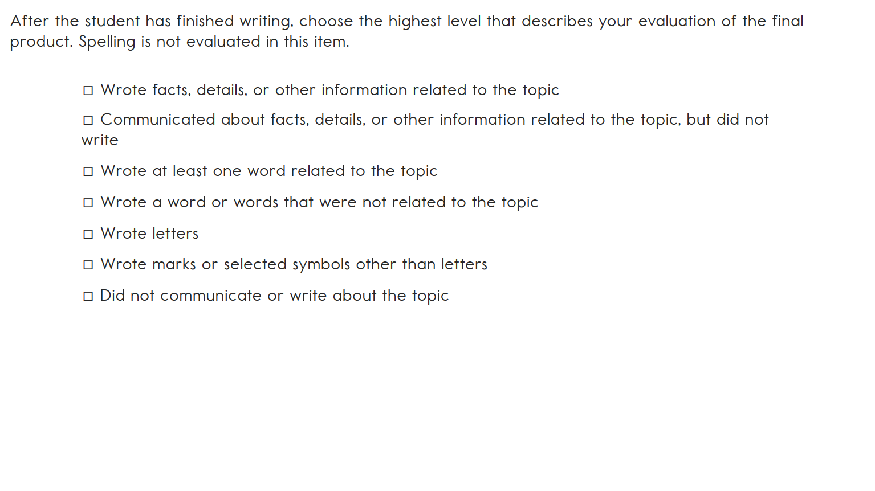
When student performance does not exactly match any response option, the test administrator selects the option that best matches the student performance.
Student’s Performance | Test Administrator’s Response
The student wrote complete sentences about the topic using at least two descriptive words. | The test administrator selects the response, “Wrote facts, details, or other information related to the topic.”
The student wrote incomplete sentences but still conveyed ideas and information about the topic using at least two descriptive words. | The test administrator selects the response, “Wrote facts, details, or other information related to the topic.”
The student did not write anything about a topic. | The test administrator selects the response, “Did not communicate or write about the topic. If that response is not available, the test administrator would choose, “No response” if available or leave the item blank.

The second type of task found in most writing testlets requires the test administrator to evaluate the student’s final writing product. The evaluation items may be in single-select or multi-select multiple-choice format. The test administrator completes this task only after the student has finished writing. The test administrator will
- look at the writing the student produced
- evaluate the student’s writing product
- choose the description that matches the highest level of the student’s writing
HINT: This task can be completed without the student present, but the task must be completed within the same assessment session. The evaluation cannot be completed if a testlet times out, after using EXIT DOES NOT SAVE, or by logging in later.

Retention of the Writing Product
Retention of a student’s writing product is a state or local decision. The assessment coordinator can provide information about those requirements (e.g., how long to store and where to store student’s writing product).
As a rule, DLM staff do not require submission of the final writing product. However, on occasion for research and technical documentation, DLM staff may request final writing products be submitted. If this request occurs, the test administrators and their assessment coordinators will be informed in advance about how and where to submit the student’s final writing product.

Teacher-Administered Reading Testlets
For teacher-administered reading testlets, the student, test administrator, and computer screen should be arranged in a triangle. Both the student and test administrator need to see or have access to the text during the shared reading activity. The test administrator is to have the best view of directions pages and item screens. When the item screens appear, the test administrator needs to be able to enter responses easily. The triangle arrangement usually works, but the test administrator may need to shift position slightly so that screens containing the ELA text can easily be displayed to both student and test administrator. Leave space near the student for any manipulatives that will be used.

Teacher-Administered Mathematics Testlets
For teacher-administered testlets in mathematics, regardless of linkage level, the test administrator is the only one who needs to view the screen to receive directions, read prompts, and enter responses. The ideal arrangement is for the student and test administrator to face one another and the test administrator can look at the computer screen off to the side.
In mathematics, the test administrator directions list materials the educator will use to administer several items. The materials used are to be both familiar to and comfortable for the student. The directions on the TIP and at the beginning of the testlet indicate when materials substitutions may be made. Whenever substituting materials, test administrators must modify the script to include the name of the actual materials used.

Teacher-Administered Science Testlets
NOTE: Check your state’s DLM webpage to see if your state tests DLM science.
The assessment arrangement for science testlets is similar to the arrangement used for mathematics testlets. Only the test administrator interacts with Student Portal. The student works outside Student Portal and interacts with the test administrator. In science, picture response cards must be printed from the TIP before test administration, and best practice is for the picture response cards to be printed in color.

Accessibility Supports
Accessibility supports that are appropriate for use during teacher-administered and computer-delivered testlets are fully described in the Accessibility Manual. Some supports are described in more detail below.

Language Translation
Because the disability-related cognitive and communication challenges for students with the most significant cognitive disabilities are unique and because English learners speak a wide variety of languages, the DLM alternate assessment does not provide translated forms of testlets. Instead, the DLM alternate assessment supplies test administrators with instructions regarding allowable supports based on each student’s unique combination of language-related and disability-related needs and on the specific construct measured by a particular testlet.
The test administrator will receive a TIP for each testlet. The TIP includes information about exceptions to the general rule of allowable translation. For example, when an item assesses knowledge of vocabulary, the TIP will include a note that the test administrator may not define terms for the student on that testlet.
Some states do not allow language translation. Check with your district assessment coordinator about language translation.
Unless exceptions are noted, test administrators may do the following:
- translate the text
- simplify testlet instructions
- translate words on demand
- provide synonyms or definitions. (Student Portal does not offer a digital dictionary.
- Students may use their version of a dictionary if needed, such as word lists and communication symbols. This dictionary is to be familiar to the student and have been used during instruction.)
- accept responses in either English or the student’s native language

Sign Interpretation
Students who are deaf or hard of hearing and who participate in the DLM alternate assessment may require additional supports beyond those available via the PNP Profile. Support needs may be different for computer-delivered testlets than for teacher-administered testlets.
Teacher-administered testlets direct the test administrator how to organize and present the content to the student. Scripted directions tell the test administrator what to say or sign. The test administrator will need to determine if the student can understand a direct translation of the script or if the student will need an interpretation of the directions. If interpretation is needed, advance planning may be necessary. Test administrators may log in to Student Portal before beginning the assessment to plan and prepare for appropriate procedures to use with students who are deaf or hard of hearing. If the need for interpretation is likely, test administrators logs in to Student Portal, launches the test, and reviews the screens to evaluate the need for interpretation. If administration will take place later, the test administrator uses the EXIT DOES NOT SAVE button (if allowed in your state) to leave the testlet.
For teacher-administered testlets, test administrators may do any of the following:
- translate the text (American Sign Language, Signed Exact English, or individualized)
- translate words on demand (e.g., English to American Sign Language)
- provide synonyms and definitions except when specifically forbidden on the TIP (e.g., when the item assesses knowledge of vocabulary)
- accept responses in the student’s sign language system (American Sign Language, Signed Exact English, or individualized) or through the student’s communication device
- reread the text if the student indicates a need

Other Practices Allowed
Students who participate in the DLM alternate assessment have access to many accessibility supports. Test administrators may also be flexible with some aspects of testlet delivery. However, testlet delivery must be standardized in certain ways. This section describes general principles for additional allowable practices when the accessibility supports included in the PNP Profile do not meet the student’s needs. When possible, the additional supports are to be consistent with the student’s current needs as documented in the IEP.
When making decisions about additional supports for computer-delivered testlets, test administrators must follow IEP team decisions and these two general principles.
- Provide flexibility in student access and response mode. For example, standard administration procedures define typical arrangements for the test administrator, student, and computer across different types of testlets. However, the test administrator may need to adapt the physical arrangement based on a student’s physical needs and use of special equipment. Another example of this flexibility is the substitution of materials as needed for the testlet.
- Maintain consistency in the student’s interaction with the concept being measured. All students do not have to interact with identical materials or respond using the same response mode, but all students do complete the same cognitive or linguistic task. Therefore, test administrators cannot rephrase questions or rearrange items. Simplified instructions, definitions, and flexible response modes are allowable supports for all students except when specifically excluded by the TIP. TIPs provide specific instructions for materials substitution to help the test administrator maintain this consistency.
To determine whether a support or practices is allowed see Practices Allowed and Practices Not Allowed, beginning on page 77 of this manual. Also, additional help can be found using the following tables in the Accessibility Manual:
- Practices not Allowed in Administering Testlets
- Allowable Practices and Accessibility Supports for Students with Individualized Student Response Modes

Testlets For Students who are Blind or have Visual Impairments

Form Types
The DLM Alternate Assessment System supplies braille forms for some testlets during the spring assessment window. These forms are available in uncontracted Unified English Braille (UEB) or English Braille American Edition (EBAE), depending on what the test administrator selects in the student’s PNP Profile. DLM braille forms also include Nemeth code as needed. Braille forms are not currently available during the instructionally embedded assessment window.
The DLM alternate assessment is designed to assess students’ knowledge, skills, and understanding of the EEs, not their ability to use braille. Therefore, braille is to be selected only if the student is proficient in reading braille. Braille is not to be selected for emerging braille readers. Other options, such as alternate forms, are suitable for a student with a visual impairment who does not read braille.
For a student who reads braille, choosing both braille (UEB or EBAE) and Alternate Form—Visual Impairment in the PNP Profile in EP provides the widest range of access. For a student with a visual impairment who does not read braille, choose only Alternate Form—Visual Impairment.

Form Availability
Braille forms and alternate forms are not available for all EEs and are not at all linkage levels. Based on availability, a student will receive one of three forms of a testlet as shown in the following list:
- A limited number of braille forms are available during the spring assessment window. See the table below for the grades, linkage levels and subject.
- A limited number of alternate forms are available during the spring assessment window.
- Standard forms are always available for the assessment.
HINT: When braille or Alternate Form—Visual Impairment are selected in the PNP Profile, other supports may also be used, such as Spoken Audio, magnification, and human read aloud.
See the table below for information about the availability of braille forms for each subject, grade, and linkage level during the spring assessment window.
Subject | Grades | Linkage Levels
ELA and mathematics | 3–5 | Target and Successor
ELA and mathematics | 6–8 and high school | Proximal Precursor, Target, and Successor
Science | 3–8 and high school | Target

Form Delivery
The test administrator marks options in the PNP Profile to have the system deliver a braille or alternate form when available. In the PNP Profile, braille is selected under the Language and Braille tab, while Alternate Form—Visual Impairment is marked under Other Supports.
When the PNP Profile is marked with both braille and Alternate Form—Visual Impairment, the forms are delivered as follows:
- If a braille form is available, the system will deliver it.
- If a braille form is not available, the system will check for an alternate form to deliver, if Alternate Form – Visual Impairment was selected in the student’s PNP Profile.
- If neither a braille form nor an alternate form is available, the system will deliver a standard form.
HINT: When appropriate, TIPs contain information about appropriate adaptations for delivering the testlet, including alternate text descriptions of pictures and/or graphics for the test administrator to read to the student.
When the system delivers a braille form, it arrives in Educator Portal as a Braille Ready File (BRF) for the test administrator to emboss. See the section Retrieve Braille Ready File in the Educator Portal User Guide for the steps to retrieve the BRF.
Braille forms are transcribed to be as similar as possible to online standard testlets, but they may contain some minor changes to help students best access or understand the information.
- Page numbers are included on all testlets to help with organization.
- Response options are lettered to help students communicate their responses so that test administrators can input the responses in Student Portal.
- Science texts are double-spaced to help students whose braille-tracking skills are not yet strong.

Tactile Graphics
Tactile graphics are a means of conveying non-textual information to people who are blind or have visual impairments. Tactile graphics may include tactile representations of pictures, maps, graphs, diagrams, and other images.
Tactile graphics are not included with the DLM braille forms. Instead, the DLM alternate assessment typically uses objects for concrete representations of content. The test administrator may use familiar objects or create tactile graphics to represent graphics that appear on screen. See the TIP for each testlet to learn about allowable objects.

Response Scoring
When the system assigns a testlet, the braille form will need to be embossed locally and provided to the student. Student Portal will also have a computer-based version of the testlet equivalent to the braille version the student receives. As students take the braille testlet on the embossed paper version, they indicate each response to the test administrator as they normally would on other braille assignments during instruction. The test administrator inputs each student response into the testlet in Student Portal. Responses are scored by the system, in the same way as non-braille forms.
When an alternate form is delivered, the testlet name will contain the letters BVI (Blind Visual Impairment) in both the test ticket and Student Portal testlet name (e.g., SP BVI SCI MS.PS1-2 P 10455).
To make a change regarding braille or alternate forms during assessment, consult the Customization for Each Student section in the Accessibility Manual.

Alternate Forms for Students Who are Blind or have Visual Impairments
Most standard testlets designed for students taking the DLM alternate assessment are accessible for students who are blind or have visual impairments. However, certain EEs are difficult to assess online for students who have visual impairments, even with supports such as Spoken Audio. For these specific EEs and linkage levels, the system will assign an alternate testlet form. Alternate forms are assigned only for certain EEs and linkage levels and only when the test administrator selects Alternate Form—Visual Impairment in the PNP Profile.
Alternate form testlet names also include BVI in the prefix (e.g., BVI Math 9.b.1 T 8711,
BVI FT ELA RI.3.8 IP 4048).

Teacher-Administered Alternate-Form Testlets
Teacher-administered testlets require the test administrator and student to complete tasks outside of Student Portal, with the test administrator recording responses in the testlet in Student Portal. These testlets will use materials that may require some advanced preparation by the test administrator. Special materials for use with students who are blind or have visual impairments are recommended, but other familiar materials may be substituted as described in Materials on page 87 of this manual. Those details are provided on the TIP.

Computer-Delivered Alternate-Form Testlets
Computer-delivered testlets for students who are blind or have visual impairments begin with an instruction screen for the test administrator and continue with content for the student to access. These testlets may require test administrators to use materials to represent the onscreen content directly to the student. Needed materials are listed on the TIP, and substitutions are allowed as directed on the TIP.

Administration of Alternate-Form Testlets
The general procedures for administering alternate form testlets are the same as those described in the previous sections. In addition, test administrators may find the following options particularly helpful when administering alternate form testlets:
- If the student also has a physical disability that makes manipulating objects difficult, take direction from the student or act on the student’s behalf by manipulating materials and selecting the responses the student has indicated.
- Provide human read aloud or system-Spoken Audio, including alternate text, for images onscreen, and describe any materials presented to the student that represent images shown on the screen.
- Change the object language in the testlet to match any substitute materials being used. For example, if the testlet uses cakes in fractional pieces and the student has been learning fractions using pizzas, pizzas may be substituted. Then also change cake to pizza when reading the text aloud.

Practices Allowed
Items in the DLM testlets are designed to assess student knowledge, skills, and understanding related to the EEs. To meet this goal, test administrators will need to use their best judgment and be flexible while administering the assessment, including providing supports beyond PNP Profile options. The following supports are allowed in computer-delivered and teacher-administered testlets, unless exceptions are noted on the TIP.

Breaks
Students may take breaks during or between testlets. Test administrators need to use their best judgment about the use of breaks. The goal is to complete a testlet in a single session; however, breaks may be needed when the student is fatigued, disengaged, or having behavioral problems that may interfere with a valid assessment of what the student knows and can do.

Individualized Student Response Mode
The items in the teacher-administered testlets do not limit responses to certain types of expressive communication; therefore, all response modes are allowed. Test administrators may need to represent response options outside the system to maximize the student’s ability to respond. For example, for students who use eye-gaze technology to communicate, test administrators may represent the response options in an alternate format or layout to ensure the student can indicate a clear response.

Special Equipment for Positioning
Some students may need special equipment to access the assessment material, such as a slant board for positioning or hook-and-loop objects on a communication board. Test administrators use the equipment to maximize the student’s ability to provide a clear response.

Navigation Across Screens
For students who have difficulty interacting directly with the computer because of a lack of experience, limited fine motor skills, or use of interactive devices, the test administrator may help students navigate across screens or enter the responses that students selected during the assessment.

Test Administrator Response Entry for Students
If a student is unable to enter a response into the computer but can indicate a response in some other fashion, such as through eye gaze, manipulatives, or verbalization, the test administrator may enter the response into the testlet on behalf of the student. Again, this system for responding to items is to be consistent with the student’s usual means of expressing choices.

Interactive Whiteboards
If a student has a severe visual impairment and needs larger presentation of content than provided by the 5x-magnification setting, the test administrator may use an interactive whiteboard or projector or a magnification device that works with the computer screen to enlarge the assessment to the needed size.
Some students do not have the fine motor skills they need to be able to select a response option on the screen of a typical average-sized computer device. When this occurs, the test administrator may project the testlet on a large whiteboard screen. Using the large display on the whiteboard screen allows students to use their gross motor skills to indicate their response options.

Alternate Representations of Response Options
Representing the response options in an alternate format is allowed, as long as the representation does not favor one response over another. For instance, the correct response cannot always be closest to the student or in the same position each time.
Text-based response options may not be represented by pictures or objects. For example, if the onscreen response options are pictures of a circle, a square, and a triangle, the educator may represent the response options using shapes on a communication board or objects that are shapes. However, response options that are words (i.e., text) may not be represented by pictures or objects.

Graphic Organizers
If the student is accustomed to using specific graphic organizers, manipulatives, or other supports during instruction, the use of those supports is allowable during the DLM alternate assessment.

Blank Paper
If the student requires blank lined or unlined paper, it may be provided to the student. However, once the student has written anything on it, the paper then becomes a secure assessment document. At the conclusion of the assessment session, the paper must be turned in to the assessment coordinator along with the TIP used during the testing session. The assessment coordinator will securely dispose of or shred the secure materials.

Use of Reinforcement
Natural or direct reinforcement may be used to promote appropriate participation in the administration of the assessment. Tangible reinforcement (e.g., stickers, tokens) or social reinforcement (e.g., praise, high fives) may be used to promote appropriate on-task behavior. These types of reinforcement can be used only for appropriate and continued participation but cannot be used to sway or lead the student to the correct response.

Generic Definitions
If the student does not understand the meaning of a word used in the assessment, the test administrator may define the term generically and allow the student to apply that definition to the item in which the term was used. Exceptions to this general rule are noted on the TIP for specific testlets.

Practices Not Allowed
Although many supports and practices are allowable for computer-delivered and teacher-administered testlets, some practices are not allowed. These practices include the following:
- repeating the item activity after a student has responded or in any other way prompting the student to choose a different response
- using physical prompts or hand-over-hand guidance to direct the student to the correct response
- removing response options or giving hints to the student
- rearranging objects to prompt the correct response (e.g., putting the correct response closer to the student)
For questions regarding whether a support is allowable, test administrators must contact their assessment coordinator. If supports outside of those that the DLM Consortium has listed are provided for a student, some states require that a description of those supports be provided through a state reporting system. To avoid invalidating the student’s assessment, follow state-specific guidelines and get approval from the assessment coordinator before using other supports.

Guidelines for Instructionally Embedded Assessments
Key Steps 80
Choose Essential Elements For Instruction 81
Select a Linkage Level 82
Review and Revise Choices 83
Retrieve Instructional Information 83
Confirm Testlet Assignment 84
Schedule and Arrange Assessment Sessions 84
Prepare to Administer an Instructionally Embedded Testlet 84
Testlet Information Pages 85
Materials 87
Familiar Texts 87
View Student Progress Reports 87

Key Steps
Test administrators prepare for and deliver instructionally embedded assessments by completing the steps below. Grey-shaded steps are described in more detail in this section. Remaining steps are defined in other Dynamic Learning Maps® (DLM®) resources listed in the Checklists for Test Administrators beginning on page 9 of this manual.
Steps
- Using information from your assessment coordinator, follow state guidelines and choose Essential Elements (EEs) for instruction.
- Retrieve instructional information for the EE.
- Record EE and linkage level choices in EP under Manage Tests > Instructional Tools as EEs become available for assessment. Instructional Tools are only available only during the instructionally embedded assessment window. See the assessment calendar on your DLM state webpage for instructionally embedded assessment windows.
- Deliver instruction until you determine the student is ready for assessment.
- Schedule a location and time for assessment sessions.
- Confirm testlet assignment in EP under Manage Tests > Instructional Tools and retrieve the Testlet Information Page (TIP). Gather needed materials before beginning assessment.
- Retrieve the student’s username and password EP under Manage Tests > Instructional Tools so the student can access the assessments in Kite® Student Portal.
- Log the student in to Student Portal to view the testlet.
- Assess the student as each testlet becomes available.
- Choose the next EE for instruction. This may be a new EE or linkage level, depending on the student’s overall instructional program for the year.
- Repeat the instruction and assessment cycle for remaining EEs and linkage levels during the instructionally embedded assessment window.
HINT: During the instructionally embedded assessment window, at least one assessment at each linkage level is available for each ELA and mathematics EE. Once a student completes a testlet, more testlets at that EE and linkage level may or may not be available. Follow your state’s guidance on frequency of assessment.

Choose Essential Elements For Instruction
NOTE: Follow state-specific guidance regarding EE choices.
Test administrators have many Essential Elements from which to choose for both instruction and assessment during the instructionally embedded assessment window. After an EE is selected, the system will make linkage-level recommendations for the EEs. The test administrator can accept the linkage level or choose a different one. Decisions about the EEs and linkage levels are to be grounded in academic priorities for the student, including priorities set in the IEP.
During the spring assessment, the Kite system selects five previously assessed EEs in ELA and five in mathematics. The system then uses results from the assessments given during instructionally embedded assessment window to determine the student’s first testlet. An example of EEs in grade 4 mathematics blueprint appears below.
Claim | Conceptual Area | EE | Description
1 | Students demonstrate increasingly complex understanding of number sense.  Choose two EEs from Claim 1 in different conceptual areas.
 | M.C1.1 | 4.NF.1-2 | Identify models of one half (½) and one fourth (¼).
 |  | 4.NF.3 | Differentiate between whole and half.
 | M.C1.2 | 4.NBT.2 | Compare whole numbers to 10 using symbols  (<, >, =).
 |  | 4.NBT.3 | Round any whole number 0–30 to the nearest ten.
 | M.C1.3 | 4.NBT.4 | Add and subtract two-digit whole numbers.

The procedure for recording EE choices for instructionally embedded assessments is described in the Use the Instructional Tools Interface (ITI) section of the Educator Portal User Guide.
HINT: Only the EEs from the current blueprint are available for assessment in the current school year and appear in the list of EE options during the instructionally embedded window.
Writing assessments have multiple EEs with different codes. Look for the EE with the primary W in the list offered in ITI.

Select a Linkage Level
For each EE, the system recommends a linkage level for each student, but the test administrator may override that choice. The linkage level that the educator selects is intended to provide an appropriate challenge for the student and also represent a good instructional target. More about the nodes at each linkage level can be found here:
- The descriptions of linkage levels in the ITI. (See the step for choosing a linkage level in section Create an Instructional Plan in the Educator Portal User Guide).
- The list of nodes for each EE in the Tested Essential Elements PDFs located on the Educator Resource Page. An example is shown below.

ELA.EE.RI.6.4 Determine how word choice changes the meaning of a text.
Initial Precursor:
- Can demonstrate a receptive understanding of the property words that describe the objects that accompany familiar games or routines
Distal Precursor:
- Can demonstrate an understanding of words with opposite meanings (e.g., cold, hot, up, down)
Proximal Precursor:
- Can demonstrate an understanding that words have different meaning or use depending on the specific context in which they are used
Target:
- Can ascertain how the meaning of an informational text is altered by the specific word choices the author makes
Successor:
- Can determine how word choice in an informational text is used to persuade or inform

Review and Revise Choices
Test administrators may review the EEs they assigned to a student. Supporting procedures for EP include the sections View Instructional Plan History and Print Instructional Plan History the Educator Portal User Guide.
Test administrators have the flexibility to change their minds about instruction (e.g., to change EE or linkage level) until the assessment is confirmed. A change may be necessary when a student has made considerable growth in the EE and the test administrator had previously selected a lower linkage level. It may also be necessary when a student experiences significant regression due to disability or absence. Supporting procedures for EP include the Cancel an Instructional Plan section in the Educator Portal User Guide.
HINT: Choosing an EE is part of planning for an instructionally embedded assessment session. This process does not apply to testlets administered during the spring assessment.

Retrieve Instructional Information
Instructional information includes the EE, a list of linkage levels and nodes, and the mini-map. These details are provided in the Tested Essential Elements PDFs located on the Educator Resource Page on the DLM website. This information is also available for each EE a test administrator chooses for instructionally embedded assessment via the ITI in EP. To learn about the steps to access instructional information, see the supporting EP procedure in the Create an Instructional Plan section of the Educator Portal User Guide.
For additional information on providing support for classroom instruction, consider reviewing the Professional Development modules. These modules are designed to support instruction on broad academic topics associated with many EEs. See Professional Development on the DLM website for access to the modules.

Confirm Testlet Assignment
After instruction is complete and the student is ready for assessment, the test administrator returns to the ITI and confirms the assignment of the EE and linkage level. Through this process, the system assigns a specific testlet to the student and provides a TIP to the test administrator.

Schedule and Arrange Assessment Sessions
Test administrators will likely need to schedule several assessment sessions during the instructionally embedded assessment window, including additional make-up sessions in case students are absent or not engaged in the assessment on the originally scheduled days.
Evaluating a student’s current behavior is very important in assessment. Not every day is a good day to assess. Therefore, use professional judgment and reschedule the assessment when needed. If the student gets tired or distracted during a testlet sooner than expected, allow the student to complete and submit the testlet and then stop testing. Another option if allowed in your state, is to stop testing using the EXIT DOES NOT SAVE button and return later. However, if EXIT DOES NOT SAVE is chosen, the student’s responses up to that point will not be saved.
Testlets may be administered in a classroom, computer lab, multipurpose room, or other school setting. However, the space must be quiet, free from distractions, and located where other students cannot see the testlet.
Recommendations for configuration of the computer, test administrator, student, and other materials are provided in Computer-Delivered Testlets on page 47 and Teacher-Administered Testlets on page 58 of this manual.
For assessment time averages and ranges, see
Duration of the Assessment Administration on page 30 of this manual.

Prepare to Administer an Instructionally Embedded Testlet
Regardless of the type of the DLM alternate assessment, educators need the following supplies when administering an assessment:
- assessment device with Kite Student Portal loaded
- student username and password
- assistive devices appropriate to the student (if needed)
- headphones for computer-Spoken Audio if other students are in the room (if needed)
- TIP

Testlet Information Pages
TIPs provide test administrators with specific information for each testlet. Test administrators receive a TIP after each testlet is assigned to a student. Test Administrators must review the TIP before beginning the student’s assessment.
HINT: When using ITI, the TIP appears in the ITI interface. During spring assessment, TIPs appear in the Test Management section of EP.
The testlet form name is included on the TIP (outlined in red in the image below).
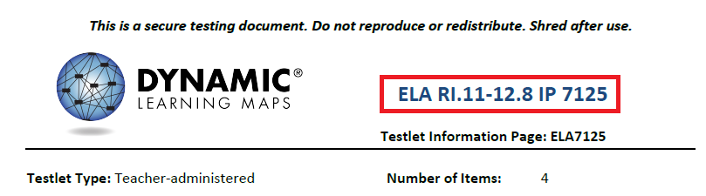
HINT: This information applies to the TIPs available for the instructionally embedded assessment window.
The TIP states whether a testlet is computer-delivered or teacher-administered and indicates the number of items on the testlet. The TIP also provides the following information for each testlet:
- Materials Needed: This field contains a list of the materials needed to administer the testlets. A description of any necessary attributes of the materials will be provided. For example, the materials may be three different small objects that are familiar to the student, each of which has a single word name (e.g., ball, pencil, and bag).
- Materials Use: This field contains a description of how the materials are used in the testlet to assess the skill. For example, the student will be able to indicate a specific object when the object’s name is used.
- Suggested Substitute Materials: Substitute materials are often allowed. This section indicates whether materials may be substituted and sometimes recommends key attributes of substitute materials.
- Accessibility Supports Not Allowed: Although a test administrator may usually use all PNP Profile supports and take advantage of the flexibility described in the Practices Allowed and Practices Not Allowed sections of this manual, see the list of Supports: Allowed and Not Allowed in the Accessibility Manual for more information. Also, the TIP will indicate when a particular support is not allowed (e.g., calculator or if other limits are included like when definitions or translation are not allowed).
- Other Comments: If a testlet has other unique instructions, they will appear here. Testlets that require special setup before test administration, such as some mathematics testlets designed for students who are blind or have visual impairments, have additional pages of instructions.
- Alternate Text: For test administrators who will be delivering human read aloud that includes descriptions of graphics, alternate text descriptions of images are provided as additional pages after the main TIP.
HINT: Instructions for alternate text for ELA are in their own section following the TIP.
TIPs for ELA testlets also provide the following information:
- the name of the text
- whether the text is informational or literature based
- whether the text is familiar or unfamiliar (Familiar texts may be downloaded from the Educator Resource Page on the DLM website and used in instruction prior to assessment.)
- the name of the grade-level text that the DLM alternate assessment text is associated with
TIPs for mathematics testlets also include the following information:
- any specific mathematics terminology used in the testlet
- whether calculator use is allowed for the testlet
- “Yes” means a student is allow to use a calculator if the student is accustomed to using a calculator for instruction. Some items in the testlet may not require a calculator, but the test administrator does not have to remove the calculator once it has been given for the testlet.
- “No” means a student cannot use a calculator for any portion of the testlet.
- “Not Applicable” means the items do not involve computation, and a calculator does not need to be provided.
Some testlets that require special setup before test administration, such as some mathematics testlets designed for students who are blind or who have visual impairments, include additional pages of instructions.

Materials
Materials used in testlets are typically easily available and are familiar to the student; therefore, the TIP includes descriptions of the general material properties that are needed to correctly assess the Essential Elements (EEs) at a linkage level. Materials that are not listed may be substituted as long as they meet the general requirements for that EE. Also, if a testlet assigned to the student contains materials that are not appropriate for that student, substitutions can be made.
Materials for the testlet must be collected prior to the assessment session. However, if the student has begun a testlet, and the materials are not working as anticipated, you may retrieve alternate materials. Student Portal can be inactive up to 90 minutes before timing out. See System Timeout on page 56 of this manual for more information about the 90-minute timeout.
The DLM website provides lists of common materials used in testlets during the instructionally embedded window. These lists are called Materials Collections.

Familiar Texts
Teacher-administered reading testlets use texts that are familiar to students and that were used during instruction. If the student is accustomed to having the familiar text read from a paper copy, the paper copy may be used during assessment. Links to printable versions of familiar texts are provided on the Educator Resource Page. Choose a grade level to see all texts for that grade.

View Student Progress Reports
A student’s participation in the instructionally embedded assessment generates a Student Progress Report. This report summarizes a student’s progress in an individual subject area. It includes only information about assessments from instructional plans selected through the ITI during the instructionally embedded assessment window. The report includes information for both the required ELA and mathematics assessments and the optional science assessment.
Test administrators may find the progress report useful when planning or reviewing instruction during the instructionally embedded assessment window. The progress report displays the tested conceptual area(s), EE, and linkage levels. The progress report contains sensitive information, including the student’s name, school, grade, and state ID number, and the report must be treated as a secure document. The progress report is a PDF that can be saved and printed.
Information about how to retrieve and read the Student Progress Report is available in the Educator Portal User Guide in the section, Access Reports and Data Extracts.

Spring Assessments
Key Steps 88
Recheck Student Information 89
Schedule and Arrange Assessment Sessions 89
Frequency of Testlet Delivery During Spring Assessment 89
Retrieve Testlet Information Page and Gather Materials 89
Testlet Information Pages 90
Materials 90
Familiar Texts 90
Other Requirements 91
Monitor Student Progress 91
Access Individual Student Score Reports 91

Key Steps
Test administrators prepare for the Dynamic Learning Maps® (DLM®) spring assessments by completing the steps below. Gray-shaded steps are described in more detail in this section. The remaining steps are defined in other DLM resources listed in the Checklists for Test Administrators on page 9 of this manual.
See your state’s DLM webpage or the state Appendix to this manual for the dates of your spring assessment window.
Step
- Recheck student demographic information, PNP Profile setting, and survey responses.
- Consider district and school assessment schedules to ensure students complete all DLM testlets during spring assessment.
- Schedule locations and times for assessment sessions.
- Retrieve the Testlet Information Page (TIP) for the first testlet and gather needed materials before beginning the assessment.
- Retrieve student’s username and password from Educator Portal (EP).
- Using Student Portal, assess student on the first testlet.
- As other testlets become available, retrieve the TIP, gather materials, and assess the student in Student Portal.

Recheck Student Information
Before your state’s spring assessment window opens, confirm that you have the correct students on your roster, that each student is assigned to the correct grade, and that their FC surveys and PNP Profiles are up to date. Contact your assessment coordinator for help editing student information.

Schedule and Arrange Assessment Sessions
Test administrators will likely need to schedule several assessment sessions, including additional make-up sessions in case students are absent or not engaged in the assessment on the days originally scheduled.
Evaluating a student’s current behavior is very important in assessment. Not every day is a good day to assess. Therefore, use professional judgment and reschedule assessment if a student is not having a good day on the intended assessment day. If the student gets tired or distracted during a testlet sooner than expected, allow the student to complete and submit the testlet and then pause assessment, or use the EXIT DOES NOT SAVE button and return later (if your state allows this option). If EXIT DOES NOT SAVE is chosen, the student’s responses will not be saved.
Testlets may be administered in a classroom, computer lab, multipurpose room, or other school setting. However, the space must be quiet, free from distractions, and located where other students cannot see the testlet.
Recommendations for configuration of the computer, test administrator, student, and other materials are provided in Computer-Delivered Testlets on page 47 and in Teacher-Administered Testlets on page 58 of this manual.
For assessment time estimates, see Duration of the Assessment Administration on page 30 of this manual.

Frequency of Testlet Delivery During Spring Assessment
Student Portal delivers only one testlet at a time in each subject. After the student takes the first testlet, Student Portal delivers the next testlet, usually within 15 minutes.

Retrieve Testlet Information Page and Gather Materials
Regardless of the subject of the DLM alternate assessment, test administrators need the following supplies when administering an assessment:
- assessment device with Student Portal loaded
- student username and password
- assistive devices appropriate to the student (if needed)
- headphones for computer-Spoken Audio if other students are in the room
- TIP

Testlet Information Pages
TIPs provide test administrators with information specific to each testlet. Test administrators receive a TIP after each testlet is assigned to a student. Review the TIP before beginning the student’s assessment.
HINT: During spring assessment, TIPs appear in the Test Management section of Educator Portal (EP). For a step-by-step procedure, see the Retrieve Testlet Information Page section of the Educator Portal User Guide. During instructionally embedded assessment, the TIP appears in ITI.
To learn more about the information included in the TIPs, see Testlet Information Pages on page 90 of this manual.

Testlet Information Pages for Science Testlets
NOTE: Check your state’s DLM webpage to see if your state tests DLM science.
TIPs for teacher-administered science testlets at the Initial linkage level are often accompanied by picture response cards. These are found on the TIP and must be printed prior to test administration. Best practice is to print picture response cards in color.

Materials
Materials used in testlets are typically easily available and familiar to the student; therefore, the TIP includes descriptions of the general material properties that are needed to correctly assess the Essential Elements (EEs) at a linkage level. Materials that are not listed may be substituted as long as they meet the general requirements for that EE. Also, if a testlet assigned to the student contains materials that are not appropriate for that student, substitutions can be made.
Materials for the testlet must be collected prior to the assessment session. However, if the student has begun a testlet and the materials are not working as anticipated, you may retrieve alternate materials. Student Portal can be inactive up to 90 minutes. See System Timeout on page 56 of this manual for more information about the 90-minute timeout.
The DLM website provides lists of common materials used in testlets during the instructionally embedded window. These lists are called Materials Collections.

Familiar Texts
Teacher-administered reading testlets use texts that are familiar to students and that were used during instruction. If the student is accustomed to having the familiar text read from a paper copy, the paper copy may be used during assessment. Links to printable versions of familiar texts are provided on the Educator Resource Page. Choose a grade level to see all texts for that grade.

Other Requirements
Regardless of the type of the DLM alternate assessment, educators need the following when administering an assessment:
- assessment device with Student Portal loaded
- student username and password
- assistive devices appropriate to the student (if applicable)
- headphones for computer-Spoken Audio if other students are in the room (if applicable)

Monitor Student Progress
On the Test Management screen in EP, the Test Progress column allows the test administrator to monitor a student’s testing progress for each subject. For each test ticket, the Test Progress column will indicate a specific testlet (e.g., Testlet 3 of 5, indicating the available testlet is the third of five required for the subject area for the grade).

Access Individual Student Score Reports
The scoring system for DLM alternate assessment is different from that of traditional alternate assessments. Students are not given raw scores, percentage-correct scores, or scale scores. Instead, the system combines a student’s responses on operational testlets using a complex algorithm to determine which linkage levels the student has likely mastered. Summative results are determined from the linkage level–mastery data. The information about each linkage level leads to a summary of the student’s mastery of skills in each conceptual area for ELA and mathematics and each domain for science, and then for each subject overall.
ELA and mathematics summative results are based on the Essential Elements (EEs) that are assessed during the instructionally embedded window and reassessed during the spring assessment window. Science summative results are based on all of the EEs on the science blueprint, which are assessed only during the spring assessment window.
The Educator Portal User Guide contains information on how to access Individual Student Score Reports. See the section, Access Reports and Data Extracts. Each state determines which roles are allowed access to the student reports in Educator Portal. In most states, test administrators receive the Individual Student Score Reports for their students from their district or building assessment coordinators instead of in Educator Portal.

Prepare for Next Year
Test administrators and IEP teams need to make certain decisions when preparing for the following school year. Two steps are described in this section.
Step
- Evaluate accessibility supports (PNP Profile settings) with IEP teams and make decisions about supports for next year.
- Plan academic IEP goals with IEP teams. Use sources of information and resources when planning a student’s IEP goals such as the blueprints for the next grade in which the student will be enrolled.

Review Blueprint
IEP teams are to review the provided blueprints for the next grade level as one source of information to plan the academic goals and prioritize the Essential Elements that will be taught the following year. Blueprints are available through your state’s DLM webpage.

Kite Student Portal User Guide
HINT: Print the following pages and keep them handy!
Kite Student Portal User Guide 93
Kite Student Portal Assessment Devices 93
Internet Connectivity 93
Kite Student Portal Procedures 94
Access Practice Activities and Released Testlets 94
Begin Operational Assessment 95
Start a Testlet 96
Navigate in Kite Student Portal 98
Spoken Audio 99
Take a Break During Assessment 100
Complete a Testlet 101
Troubleshoot in Kite Student Portal 101

HINT: Students access Kite Student Portal with their own usernames and passwords. Staff and educators do not have accounts in Student Portal.

Kite Student Portal Assessment Devices
Dynamic Learning Maps® (DLM®) alternate assessments may be administered on devices. See the Kite Suite page on the DLM website for specific information.
Using multiple assessment devices to administer a single testlet is not recommended. This means is that a student is not to begin testing on one device and then attempt to complete the testlet on another device.

Internet Connectivity
An Internet connection is required to deliver assessments using Student Portal. Contact the assessment coordinator or local technology personnel for help with Internet connectivity.

Kite Student Portal Procedures

Access Practice Activities and Released Testlets
HINT: Student Portal must be installed before accessing practice activities or released testlets. Download information is available on the Kite page of the DLM website: http://dynamiclearningmaps.org/kite.
To access DLM practice activities and released testlets, follow these steps.
- Click the Student Portal icon on the testing device.
- Enter the practice student username and password. Click SIGN IN.
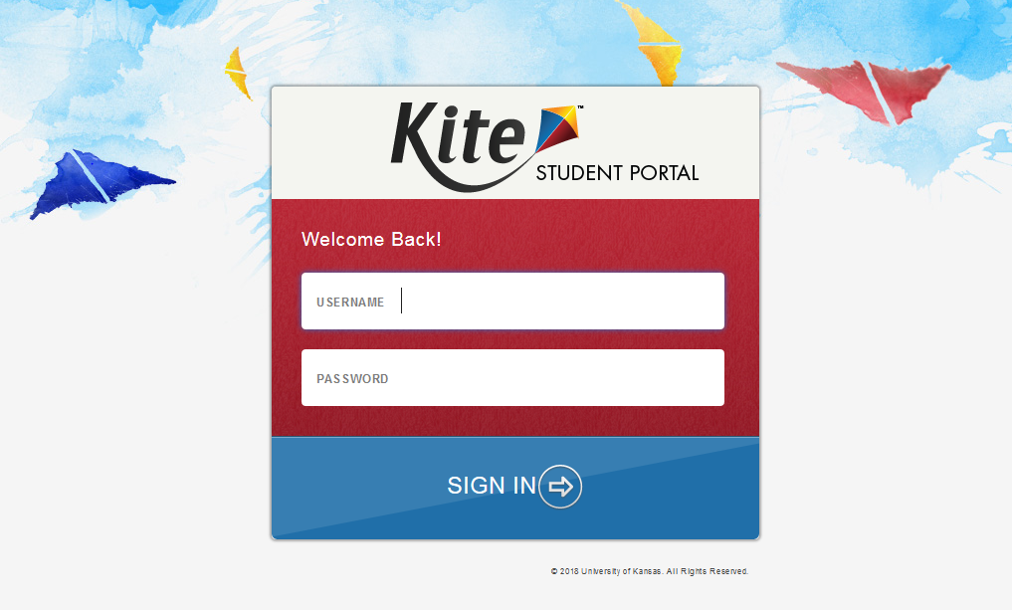
- Click PRACTICE FIRST.
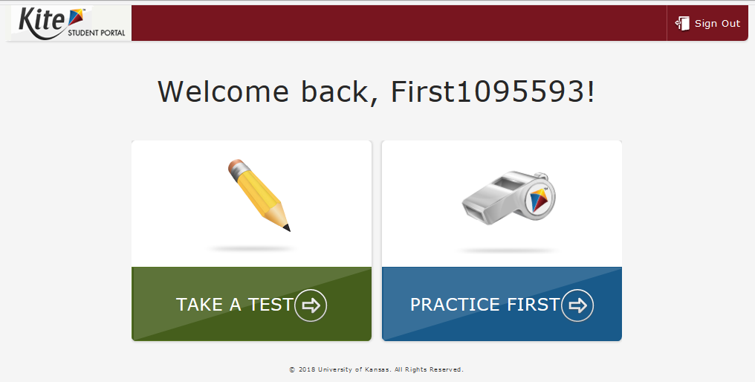
- Select the appropriate subject and scroll through the pages to select a test. Click Take Test for the desired practice activity or released testlet.
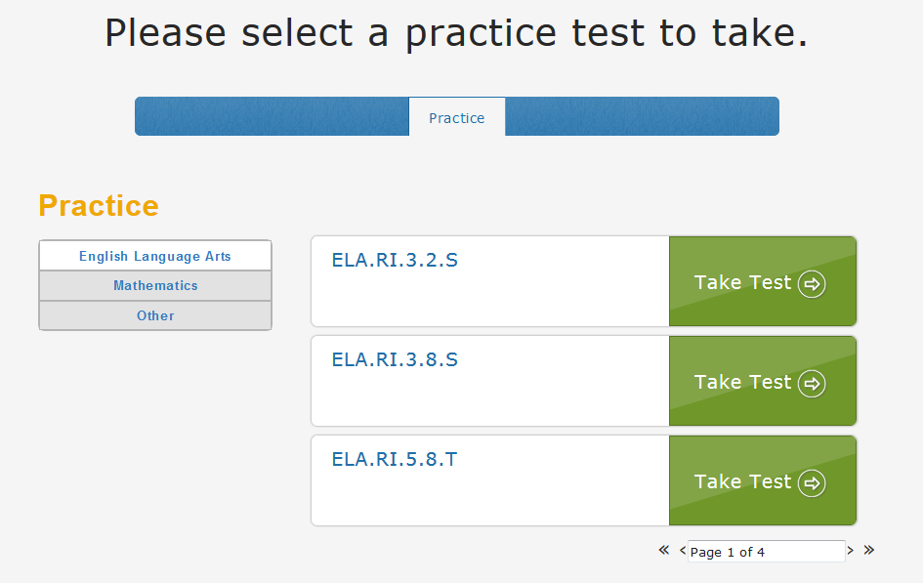
- Click BEGIN.
- Continue with the testlet, using the BACK and NEXT buttons to navigate. To stop in the middle of a testlet, click EXIT DOES NOT SAVE.
To try a different student profile or a different released testlet or practice activity, complete a testlet or click EXIT DOES NOT SAVE to return to the welcome screen. Then sign out and sign back in with a different username and password.

Begin Operational Assessment
To begin the operational assessment, first confirm that you have the student’s username and password to log in to Student Portal. Each student’s username and password are the same for all of their DLM alternate assessments. These are available in two places:
- The first place a test administrator can view the student’s user name and password is in Educator Portal on the View Student screen. The test administrator gains this access as soon as the security agreement is signed and the Required Test Administrator Training is successfully completed. However, testlets will not be available until the assessment window opens.
- The second place a test administrator can view the student’s user name and password is in Educator Portal on the Test Management screen in the Test Ticket Column. The student’s login information will be available here once the assessment window opens and the first testlet is assigned.

Start a Testlet
To administer a DLM alternate assessment, follow these steps.
- Click the Kite Student Portal icon on the testing device.
- Enter the student’s username and password. Click SIGN IN.
- Click TAKE A TEST.
- Click Take Test for the desired test. Only one testlet is visible at a time.
- Click BEGIN.
HINT: iPads have an auto-lock feature preventing users from using other apps while Student Portal is in use.

Navigate in Kite Student Portal
Navigate in Student Portal with these buttons.
Button | Action
Visible on each test screen (See the example below.)
 | Return to the previous screen.
 | Go to the next screen.
 | Read the text aloud. This button appears when the student has Spoken Audio enabled in the Personal Needs and Preferences (PNP) Profile.
 | Exit the testlet without saving responses. Upon return, the student will start at the beginning of this testlet.
Available on the review screen at the end of the testlet. (See the review screen under Complete a Testlet on page 101 of this manual.)
 | Go back to review or change responses for this testlet.
 | Save responses and end this testlet.

The following image shows the buttons available on each testlet screen.

Spoken Audio
When spoken (synthetic) audio is enabled in a student’s PNP Profile, a READ button with an icon will appear at the bottom of the screen next to the EXIT DOES NOT SAVE button. To start the Spoken Audio, students may click either READ or the icon to start the Spoken Audio, since they work in unison.
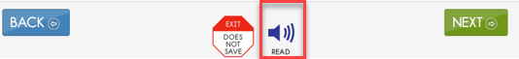
As soon as Spoken Audio is enabled, a diagonal red line appears across the icon and the word READ changes to PAUSE.
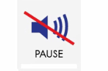
The synthetic voice continues reading until all sentences or response options on the screen have been read or the student clicks PAUSE.
If the student clicks PAUSE, the Spoken Audio stops. The icon changes back to READ, and the icon becomes uncrossed again. To begin the synthetic voice reading again, the student clicks READ and the Spoken Audio resumes.
Additionally, while the synthetic voice is reading, the sentences or response options on the screen are highlighted in yellow, one sentence or one response option at a time. If the student wants to hear the sentences or response options again or see the highlighting of them, the students may select READ repeatedly to reactivate Spoken Audio on any individual screen as many times as needed. Once the student is ready to move on, the student clicks the NEXT button to move to the next screen and begin the process again.

Take a Break During Assessment
DLM testlets have no time limits or limits on the use of breaks during assessment. A student may take a break during assessment in one of three ways:
- Take a short break (up to 90 minutes).
After 88 minutes and 30 seconds of inactivity in the testlet, the system provides this warning message: EXTEND SESSION or LOGOUT. After the 90 seconds expire, Student Portal closes the session automatically and does not save responses.
- Take a break between testlets.
After clicking END at the conclusion of a testlet, log out of Student Portal. Log back in when the student is ready to take the next testlet. Stop in the middle of a testlet using the EXIT DOES NOT SAVE button (allowed only in some states).
When available, this button appears on every testlet screen.
This screen appears when choosing EXIT DOES NOT SAVE.
- Click YES to exit the testlet without saving the student’s work. When the student returns to the testlet, the testlet will start at the beginning.
- Click NO to continue with the testlet rather than exiting. If you continue, you can save the work at the end of the testlet by clicking END on the review screen.

Complete a Testlet
This review screen appears at the end of a testlet.
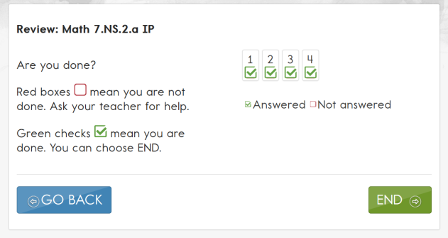
To complete the testlet, follow these steps:
- Click END.
- This confirmation message asks, “Are you sure you want to end?”
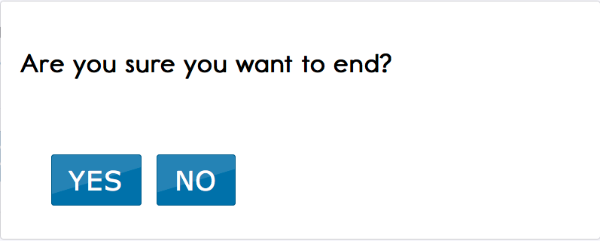
- Click YES. (You will not be able to return to the testlet after clicking YES.)
- Click Close Kite.
- Click YES in response to “Are you sure you want to exit?”

Troubleshoot in Kite Student Portal
If you see scroll bars when magnification is not selected in the PNP Profile, the student’s display has technology issues. Try using a different device to correct the situation or contact your district technology staff for help.
For more help with common Student Portal problems, see the Troubleshooting Kite Errors page at http://dynamiclearningmaps.org/kite-troubleshooting.

References
Mineo Mollica, B. (2003). Representational competence. In J. C. Light, D. R. Beukelman, & J. Reichle (Eds.), Communicative competence for individuals who use AAC: From research to effective practice (pp. 107–146). Baltimore, MD: Paul H. Brookes.
Romski, M., & Sevcik, R. (1996). Breaking the speech barrier: Language development through augmented means. American Journal on Mental Retardation, 102(3).
Romski, M., & Sevcik, R. (2005). Augmentative communication and early intervention: Myths and realities. Infants & Young Children, 18(3), 174–185. http://dx.doi.org/10.1097/00001163-200507000-00002
Sinharay, S., Wan, P., Whitaker, M., Kim, D., Zhang, L., Choi, S. W. (2014). “Determining the overall impact of interruptions during online testing.” Journal of Educational Measurement. 51(4) doi: 10.1111/jedm.12052

GLOSSARY
This glossary compiles definitions and acronyms relevant to the Dynamic Learning Maps® (DLM®) alternate assessment.

claim | ELA and mathematics: A broad statement about what the DLM Consortium expects students to learn and to be able to demonstrate within English language arts and mathematics. Each claim is subdivided into two or more conceptual areas.
conceptual area | ELA and mathematics: A region within the DLM learning map containing nodes associated with related Essential Elements, representing concepts and skills that support the learning of the Essential Elements in English language arts and mathematics. Conceptual areas are composed of clusters of connected concepts and skills and serve as models of how students may acquire and organize their content knowledge. Conceptual areas are considered subparts of the overall claims.
connection | ELA and mathematics: The relationship between two nodes in the DLM maps. Connections are illustrated with arrows in the maps.
core idea | Science: Core ideas are the key organizing principles in science and are taught and learned over multiple grades at increasing levels of depth and sophistication.  For science, within each domain, three or four core ideas have been selected to use for instruction and assessment. Each of the core ideas is narrowed further into topics.
domain | Science: The major science content areas assessed are domains. The domains assessed across all grade bands are physical science, life science, and Earth and space science.
Educator Portal (EP) | Educator Portal (EP) is the administrative application where staff and educators manage student data and retrieve reports. Users can access EP via https://educator.kiteaa.org. For information on working within EP, see the Data Management Manual and the Educator Portal User Guide on the DLM website.
engagement activity | An activity at the beginning of a testlet that describes a scenario, taps prior knowledge or experience, and/or introduces the concept to be addressed. In English language arts reading testlets, the first reading of the text often serves as the engagement activity. In mathematics and science, the engagement activity provides context for the items. Some science testlets at the upper linkage levels have a short video.
Essential Elements (EEs) | Specific statements of knowledge and skills linked to the grade-level expectations identified in K-12 grade-level standards for English language arts and mathematics. Essential Elements in science are linked to the National Research Council’s Framework for K-12. Essential Elements build a bridge from the content in the grade-level standards to academic expectations for students with the most significant cognitive disabilities.
First Contact (FC) survey | A survey used to collect background information about students who are eligible for the DLM alternate assessments. The survey goes beyond basic demographic information and includes questions on communication, assistive technology devices, motor and sensory impairments, and academic performance. Core questions from the FC are used to determine a student’s first testlet, or initialization, into the assessment.
instructional plan | A plan, created through the Educator Portal Instructional Tools Interface, which includes the selected Essential Element and linkage level and leads to assignment of an instructionally embedded assessment during the instructionally embedded assessment window.
instructionally embedded assessment | Assessment that occurs throughout instruction in the instructionally embedded assessment window during the fall and winter months.
Instructional Tools Interface (ITI) | A tool in Educator Portal that allows a test administrator to create an instructional plan. The test administrator selects an Essential Element and accepts the system recommended linkage level or chooses a different linkage level for a student. An instructionally embedded assessment is generated based on those choices.
Kite® Student Portal | A secure customized interface used to deliver assessments to students. All students taking the DLM alternate assessment will have unique accounts in Kite Student Portal. Test administrators do not have accounts in Student Portal. See the Test Administration Manual for more information about Student Portal.
linkage level | ELA and mathematics: A small section of the DLM map containing one or more nodes that represent critical concepts or skills needed to learn the EE. See the Test Administration Manual for more information about the number and names of linkage levels for each DLM subject.  Science: An incremental level of complexity toward the learning target where an assessment was developed for that particular EE. Science has three linkage levels: Initial, Precursor, and Target. Linkage levels are always related directly to grade-level EEs but at different levels of cognitive complexity. The Target level is most closely related to the grade-level expectation.
materials | Materials generically refer to any objects, manipulatives, and tools used during an assessment. Materials lists for the instructionally embedded window and the spring assessment window are found on each state’s DLM website under Educator Resources. The Testlet Information Page (TIP) for each testlet provides materials or the attributes of a material needed for administering that particular testlet. The materials listed in the TIP are especially needed for the teacher-administered testlets at the Initial and Distal Precursor linkage levels in ELA and mathematics, and the Initial linkage level for science.
node | ELA and mathematics: A representation in the DLM learning maps of an individual skill or conceptual understanding identified in the research in ELA and mathematics.
Personal Learning Profile | This is a collective term used to describe a student’s personal needs and preferences settings entered in the PNP Profile in addition to information about the student entered in the First Contact survey in Educator Portal.
Personal Needs and Preferences (PNP) Profile | Student-specific information that informs Kite Student Portal about an individual student’s personal needs and preferences. The PNP Profile includes information the system needs to make the student’s user interface compatible with their accessibility needs. In Educator Portal, the PNP Profile includes information about display enhancements, language and braille, and audio and environmental supports. Educators who know the student provide the information in the profile.
released testlets | A released testlet is a publicly available, sample DLM assessment. Released testlets may be used by students and teachers as examples or opportunities for practice. Released testlets are developed using the same standards and methods used to develop testlets that are used in DLM operational assessments. New released testlets are added periodically.
stem | The stem is the beginning part of the item that presents a problem to solve or an item to respond to. The stem may also include other relevant information in the item. A multiple choice item is a common example in the DLM alternate assessment, consisting of a stem and a set of response options from which to choose.
testlet | Short for instructionally relevant testlet. A testlet begins with an engagement activity and is followed by several items that together increase the instructional relevance of the assessment and provide a better estimate of a student’s knowledge, skills, and understandings than can be achieved by a single assessment item. Each testlet has three to nine items depending on the subject. More specific information is found in the Test Administration Manual.
Testlet Information Page (TIP) | A PDF that is unique to each testlet and provides specific information to guide the test administrator in delivering the assessment.

Dynamic Learning Maps® Appendix

Appendix A. Number of Testlets for Spring Assessment
This chart shows the number of operational testlets to expect during spring assessment. It is organized by grade for each subject area.
Grade | Mathematics Testlets | ELA Testlets | Science Testlets | Field Test Testlets*
3 | 5 | 5 | 9 | 0 or 1
4 | 5 | 5 | 9 | 0 or 1
5 | 5 | 5 | 9 | 0 or 1
6 | 5 | 5 | 9 | 0 or 1
7 | 5 | 5 | 9 | 0 or 1
8 | 5 | 5 | 9 | 0 or 1
9 | 5 | 5 | 9* | 0 or 1
10 | 5 | 5 | 9* | 0 or 1
11 | 5 | 5 | 9* | 0 or 1
12 | 0 | 5 | 9* | 0 or 1

HINT: Check your state’s DLM webpage to see if your state tests DLM science. For states testing end-of-instruction biology in high school, students would receive ten testlets.
*Field Test Testlets in the spring are delivered after all operational testlets in a subject have been submitted.

Appendix B. First Contact Survey (All Questions)
Current. No changes since 3/10/16.
The questions asked in the First Contact (FC) survey are included here. The test administrator completes the FC survey in Educator Portal (EP). Only users with an EP role of District Test Coordinator, Building Test Coordinator, or Teacher have permission to enter student information in the FC survey. Other roles have permission only to view.
Asterisks indicate items that are required for all states. Other questions may be required based on state-specific directions.
HINT: The status Not Applicable is possible in the FC survey column, but it is not common. However, because this option is so rare, check that you are logged in as a DLM user and that the student’s information has been loaded properly into the system.

Special Education
Special Education Services
Select the student’s Primary Disability*
- autism
- deaf-blindness
- deafness
- developmental delay
- emotional disturbance
- hearing impairment
- intellectual disability
- multiple disabilities
- orthopedic impairment
- other health impairment
- specific learning disability
- speech or language impairment
- traumatic brain injury
- visual impairment, including blindness
- non-categorical
- eligible individual
Educational Placement: Choose the option that best describes the student’s educational placement. “Regular Class” means a typical classroom, not a resource room or separate class.*
- 80% or more of the day in Regular Class
- 40% - 79% of the day in Regular Class
- Less than 40% of the day in Regular Class
- Separate School: includes public or private separate day school for students with disabilities, at public school expense
- Residential Facility: includes public or private separate residential school for students with disabilities, at public school expense
- Homebound/Hospital Environment: includes students placed in and receiving special education in a hospital or homebound program

Sensory Capabilities
Hearing
Hearing*
- No hearing loss suspected/documented
- Questionable hearing but testing inconclusive
- Deaf or hard of hearing
Classification of Hearing Impairment*
- Mild (26-40 dB loss)
- Moderate (41-55 dB loss)
- Moderately Severe (56-70 dB loss)
- Severe (71-90 dB loss) 5. Profound (91+ dB loss)
- Unknown
Hearing: Mark all that apply*
- Uses personal or classroom amplification (e.g., personal FM device)
- Uses unilateral hearing aid
- Uses bilateral hearing aid
- Has cochlear implant
- Uses oral language
- Uses sign language
Vision
Vision*
- No vision loss suspected or documented
- Normal vision with glasses or contact lenses
- Blind or low vision, including vision that is not completely corrected with glasses or contact lenses
- Questionable vision but testing inconclusive
Classification of Visual Impairment Mark all that apply*
- Low Vision (acuity of 20/70 to 20/200 in the better eye with correction.)
- Legally Blind (acuity of 20/200 or less or field loss to 20 degrees or less in the better eye with correction.)
- Light Perception Only
- Totally Blind
- Cortical Visual Impairment
Vision: Mark all that apply*
- Requires enlarged print
- Requires tactile media (objects, tactile graphics, and tactile symbols)
- Requires or uses Braille
- Uncontracted Braille
- Contracted Braille
- UEB
Technological Visual Aids: Mark all that apply*
- Screen magnification device (fits over standard monitor) or software (e.g., Closeview for Mac, ZoomText)
- CCTV
- Screen reader and/or talking word processor
- Manual (e.g., Perkins Brailler) or Electronic (e.g., Mountbatten Brailler) Braille writing device
- Device with refreshable Braille display

Motor Capabilities and Health
Arm/ Hand Control and Health
Arm and hand control: Mark all that apply*
- Uses two hands together to perform tasks
- Uses only one hand to perform tasks
- Requires physical assistance to perform tasks with hands
- Cannot use hands to complete tasks even with assistance

Does the student have any health issues (e.g., fragile medical condition, seizures, therapy or treatment that prevents the student from accessing instruction, medications, etc.) that interfere with instruction or assessment?*
- No
- Yes

Computer Instruction
Computer Use and Instruction
Computer Use: Select the student’s primary use of a computer during instruction*
- Accesses a computer independently
- Accesses a computer independently given assistive technology
- Uses a computer with human support (with or without assistive technology)
- This student has not had the opportunity to access a computer
- This student cannot access a computer with human or assistive technology support
Why has this student not had the opportunity to access a computer during instruction?*
- Student’s disability prevents the student from accessing a computer
- The equipment is unavailable
- Student refuses to try to use a computer
- I (or other educators) at this school have not had the opportunity to instruct the student on computer usage
Computer access during instruction: Mark all that apply*
- Standard computer keyboard
- Keyboard with large keys or alternative keyboard (e.g., Intellikeys)
- Touch screen (e.g., touch screen computer, tablet, iPad, iPod touch)
- Standard mouse or head mouse
- Eye gaze technology (e.g., Tobii, EyeGaze Edge)
- Scanning with switches (one or two-switch scanning)
Level of attention to computer-directed instruction*
- Generally sustains attention to computer-directed instruction
- Demonstrates fleeting attention to computer-directed instructional activities and requires repeated bids or prompts for attention
- Demonstrates little or no attention to computer-directed instructional activities

Level of attention to teacher-directed instruction*
- Generally sustains attention to teacher-directed instruction
- Demonstrates fleeting attention to teacher-directed instructional activities and requires repeated bids or prompts for attention
- Demonstrates little or no attention to teacher-directed instructional activities

Communication
Expressive Communication
Does the student use speech to meet expressive communication needs?*
- Yes
- No
Choose the highest statement that describes the student’s expressive communication with speech*
- Regularly combines 3 or more spoken words according to grammatical rules to accomplish a variety of communicative purposes (e.g., sharing complex information, asking/answering longer questions, giving directions to another person)
- Usually uses 2 spoken words at a time to meet a variety of more complex communicative purposes (e.g., obtaining things including absent objects, social expressions beyond greetings, sharing information, directing another person’s attention, asking/answering questions, and commenting)
- Usually uses only 1 spoken word at a time to meet a limited number of simple communicative purposes (e.g., refusing/rejecting things, making choices, requesting attention, greeting, and labeling)
Does the student use sign language in addition to or in place of speech to meet expressive communication needs?*
- Yes
- No
Choose the highest statement that describes the student’s expressive communication with sign language*
- Regularly combines 3 or more signed words according to grammatical rules to accomplish a variety of communicative purposes (e.g., sharing complex information, asking/answering longer questions, giving directions to another person)
- Usually uses 2 signed words at a time to meet a variety of more complex communicative purposes (e.g., obtaining things including absent objects, social expressions beyond greetings, sharing information, directing another person’s attention, asking/answering brief questions, and commenting)
- Usually uses only 1 signed word at a time to meet a limited number of simple communicative purposes (e.g., refusing/rejecting things, making choices, requesting attention, greeting, and labeling)
Select the student’s primary sign system*
- American Sign Language (ASL)
- Signed Exact English (SEE)
- Hybrid or idiosyncratic/personalized signing system
Expressive Communication
Does the student use augmentative or alternative communication in addition to or in place of speech or sign language to meet expressive communication needs?*
- Yes
- No
Choose the highest statement that describes the student’s expressive communication with augmentative or alternative communication*
- Regularly combines 3 or more symbols according to grammatical rules to accomplish the 4 major communicative purposes (e.g., expressing needs and wants, developing social closeness, exchanging information, and fulfilling social etiquette routines)
- Usually uses 2 symbols at a time to meet a variety of more complex communicative purposes (e.g., obtaining things including absent objects, social expressions beyond greetings, sharing information, directing another person’s attention, asking/answering brief questions, commenting)
- Usually uses only 1 symbol to meet a limited number of simple communicative purposes (e.g., refusing/rejecting things, making choices, requesting attention, greeting)
Expressive Communication
How many symbols does the student choose from when communicating? (choose the highest that applies)*
- 1 or 2 at a time
- 3 or 4 at a time
- 5 to 9 at a time
- 10 or more at a time
What types of symbols does the student use? (choose all that apply)*
- Real objects
- Tactual symbols
- Photos
- Line drawing symbol sets (Boardmaker, PCS, Symbol Stix, other)
- Text Only
What voice output technology does the student use? (choose all that apply)*
- Single message devices (e.g., BIGmac)
- Simple devices (e.g., GoTalk; QuickTalker; SuperTalker)
- Speech generating device (e.g., Tobii-DynaVox, PRC/PrentkeRomich)
- None
If the student does not use speech, sign language, or augmentative or alternative communication, which of the following statements best describes the student’s expressive communication? Choose the highest statement that applies
- Uses conventional gestures (e.g., waving, nodding and shaking head, thumbs up/down), looking, pointing, and/or vocalizations to communicate intentionally but does not yet use symbols or sign language
- Uses only unconventional vocalizations (e.g., grunts), unconventional gestures (e.g., opening mouth wide to indicate hunger), and/or body movement to communicate intentionally
- Exhibits behaviors that may be reflexive and are not intentionally communicative but can be interpreted by others as communication (e.g., crying, laughing, reaching for an object, pushing an object away)
Receptive Communication
Receptive communication: MARK EACH ONE to show how consistently the student uses each skill. 1) 0% - 20% of the time - Almost never, 2) 21% - 50% of the time - Occasionally, 3) 51 – 80% of the time - Frequently, 4) More than 80% of the time - Consistently
If the student previously demonstrated and no longer receives instruction, mark “More than 80%.”*
- can point to, look at, or touch things in the immediate vicinity when asked (e.g., pictures, objects, body parts)
- can perform simple actions, movements or activities when asked (e.g., comes to teacher’s location, gives an object to teacher or peer, locates or retrieves an object)
- responds appropriately in any modality (sign, gestures, facial expressions) when offered a favored item that is not present or visible (e.g., "do you want some ice cream?")
- responds appropriately in any modality (sign, gestures, facial expressions) to single words that are spoken or signed
- responds appropriately in any modality (sign, gestures, facial expressions) to phrases and sentences that are spoken or signed
- follows 2-step directions presented verbally or through sign (e.g., gets a worksheet or journal and begins to work, distributes items needed by peers for a lesson or activity, looks at requested or desired item and then looks at location where it should go)

Language
Primary Language
Is English the student’s primary language? *
- Yes
- No
Is English the primary language spoken in the student’s home?*
- Yes
- No
- Unknown
Is English the primary language used for the student’s instruction?*
- Yes
- No

Academic
*Reading Skills – Entire Section is Required
Reading skills: MARK EACH ONE to show how consistently the student uses each skill. 1) 0% - 20% of the time - Almost never, 2) 21% - 50% of the time - Occasionally, 3) 51 – 80% of the time - Frequently, 4) More than 80% of the time - Consistently
If the student previously demonstrated and no longer receives instruction, mark “More than 80%.”*
- Recognizes single symbols presented visually or tactually (e.g., letters, numerals, environmental signs such as restroom symbols, logos, trademarks, or business signs such as fast food restaurants)
- Understands purpose of print or Braille but not necessarily by manipulating a book (e.g., knows correct orientation, can find beginning of text, understands purpose of text in print or Braille, enjoys being read to)
- Matches sounds to symbols or signs to symbols (e.g., matches sounds to letters presented visually or tactually, matches spoken or signed words to written words)
- Reads words, phrases, or sentences in print or Braille when symbols are provided with the words
- Identifies individual words without symbol support (e.g., recognizes words in print or Braille; can choose correct word using eye gaze)
- Reads text presented in print or Braille without symbol support but WITHOUT comprehension
- Reads text presented in print or Braille without symbol support and WITH comprehension (e.g., locates answers in text, reads and answers questions, retells after reading, completes maze task)
- Explains or elaborates on text read in print or Braille

Reading Skills

Student’s approximate instructional level of reading text with comprehension (print or braille): Mark the highest one that applies*
- Above third grade level
- Above second grade level to third grade level
- Above first grade level to second grade level
- Primer to first grade level
- Reads only a few words or up to pre-primer level
- Does not read any words when presented in print or Braille (not including environmental signs or logos)
Math Skills Entire Section is required*
Math skills: MARK EACH ONE to show how consistently the student uses each skill. 1) 0% - 20% of the time - Almost never, 2) 21% - 50% of the time - Occasionally, 3) 51 – 80% of the time - Frequently, 4) More than 80% of the time - Consistently
If the student previously demonstrated and no longer receives instruction, mark “More than 80%.”*
- Creates or matches patterns of objects or images
- Identifies simple shapes in 2 or 3 dimensions (e.g., square, circle, triangle, cube, sphere)
- Sorts objects by common properties (e.g., color, size, shape)
- Counts more than two objects
- Adds or subtracts by joining or separating groups of objects
- Adds and/or subtracts using numerals
- Forms groups of objects for multiplication or division
- Multiplies and/or divides using numerals
- Uses an abacus
- Uses a calculator
- Tells time using an analog or digital clock
- Uses common measuring tools (e.g., ruler or measuring cup)
- Uses a schedule, agenda, or calendar to identify or anticipate sequence of activities

Writing Skills Entire Section is Required*
Indicate the highest level that describes the student’s writing skills. Choose the highest level that the student has demonstrated even once during instruction, not the highest skill demonstrated consistently.
Writing includes any method the student uses to write using any writing tool that includes access to all 26 letters of the alphabet. Examples of these tools include paper and pencil, traditional keyboards, alternate keyboards and eye-gaze displays of letters.*
- Writes paragraph length text without copying using spelling (with or without word prediction)
- Writes sentences or complete ideas without copying using spelling (with or without word prediction)
- Writes words or simple phrases without copying using spelling (with or without word prediction)
- Writes words using letters to accurately reflect some of the sounds
- Writes using word banks or picture symbols
- Writes by copying words or letters
- Scribbles or randomly writes/selects letters or symbols

Science Skills Entire Section is required* (This section is only visible for states administering the DLM science assessment.)
Science skills: MARK EACH ONE to show how consistently the student uses each skill. 1) 0% - 20% of the time - Almost never, 2) 21% - 50% of the time - Occasionally, 3) 51 – 80% of the time - Frequently, 4) More than 80% of the time - Consistently
If the student previously demonstrated and no longer receives instruction, mark “More than 80%.”*
- Sorts objects or materials by common properties (e.g., color, size, shape)
- Identifies similarities and differences
- Recognizes patterns
- Compares initial and final conditions to determine if something changed.
- Uses data to answer questions.
- Identifies evidence that supports a claim.
- Identifies cause and effect relationships.
- Uses diagrams to explain phenomena.
End of Survey

Appendix C. Spring Assessment: Testlet Assignment
For the spring ELA and mathematics assessments, the DLM adaptive algorithm assigns each student five testlets in ELA and five in mathematics. The Kite system assigns testlets according to a student’s history in the Instructional Tools Interface (from the instructionally embedded assessment window) to assign testlets based on what the student has already done.
For states that use the DLM science assessment, assignment of the first science testlet is based solely on students’ First Contact survey information, even if the student tested during the instructionally embedded assessment window. Students take nine science testlets. In states administering biology end-of-instruction in high school, the students will take a total of ten testlets.
Each testlet includes items from one EE on the test blueprint. The testlets are assigned, one at a time; each subsequent testlet is assigned according to the adaptive algorithm.
The image below shows a blueprint with one criterion selected.
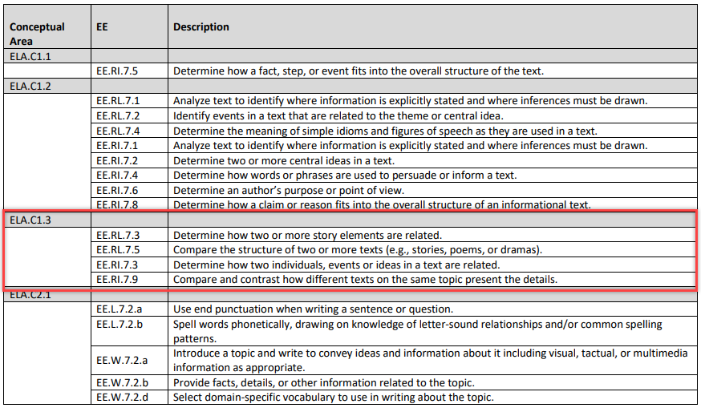

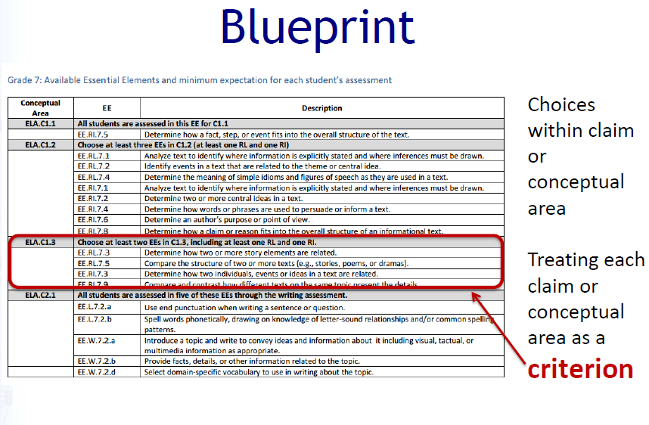
Adaptive Algorithm
The system goes through each criterion, one at a time. When there are fewer than five criteria on a blueprint, the system picks once from each criterion and selects the remaining testlets from areas in which EEs are available. The system will pick testlets for EEs on which the student was previously assessed unless the student was not fully assessed on the minimum blueprint requirement during instructionally embedded assessment. The chart below shows a complete blueprint for seventh-grade ELA. A total of four criteria must be met, one for each of several conceptual areas. For two conceptual areas (i.e., ELA.C1.1 and ELA C2.1), all students were already assessed in the EEs. For two other conceptual areas (i.e,. ELA.C1.2 and ELA.C.1.3), several EEs are available to choose from for assessment.
Grade 7 ELA Blueprint
Conceptual Area | EE | Description
ELA.C1.1 | All students are assessed in this EE for C1.1.
 | EE.RI.7.5 | Determine how a fact, step, or event fits into the overall structure of the text.
ELA.C1.2 | Choose at least three EEs in C1.2 (at least one RL and one RI)
 | EE.RL.7.1 | Analyze text to identify where information is explicitly stated and where inferences must be drawn.
 | EE.RL.7.2 | Identify events in a text that are related to the theme or central idea.
 | EE.RL.7.4 | Determine the meaning of simple idioms and figures of speech as they are used in a text.
 | EE.RI.7.1 | Analyze text to identify where information is explicitly stated and where inferences must be drawn.
 | EE.RI.7.2 | Determine two or more central ideas in a text.
 | EE.RI.7.4 | Determine how words or phrases are used to persuade or inform a text.
 | EE.RI.7.6 | Determine an author’s purpose or point of view.
 | EE.RI.7.8 | Determine how a claim or reason fits into the overall structure of an informational text.

ELA.C1.3 | Choose at least two EEs in C1.3, including at least one RL and one RI.
 | EE.RL.7.3 | Determine how two or more story elements are related.
 | EE.RL.7.5 | Compare the structure of two or more texts (e.g., stories, poems, or dramas).
 | EE.RI.7.3 | Determine how two individuals, events, or ideas in a text are related.
 | EE.RI.7.9 | Compare and contrast how different texts on the same topic present the details.
ELA.C2.1 | All students are assessed in five of these EEs through the writing assessment.
 | EE.L.7.2.a | Use end punctuation when writing a sentence or question.
 | EE.L.7.2.b | Spell words phonetically, drawing on knowledge of letter-sound relationships and/or common spelling patterns.
 | EE.W.7.2.a | Introduce a topic and write to convey ideas and information about it including visual, tactual, or multimedia information as appropriate.
 | EE.W.7.2.b | Provide facts, details, or other information related to the topic.
 | EE.W.7.2.d | Select domain-specific vocabulary to use in writing about the topic.
HINT: Writing is always one of the five testlets during spring assessment. The writing testlet covers multiple EEs and is required for all students.

Imagine three students who enter the spring assessment with different experiences with the DLM alternate assessment. The table below describes how each student might receive the first four testlets.
Conceptual Area | Student 1  Completed all blueprint requirements during instructionally embedded assessment | Student 2  Completed some blueprint requirements during instructionally embedded assessment (criteria for 1.1 and 1.2) | Student 3  Completed none of the blueprint requirements during instructionally embedded assessment
Testlet 1  (1.1) | EE.RI.7.2  Linkage level assigned according to performance during instructionally embedded assessment | EE.RI.7.2  Linkage level assigned according to performance during instructionally embedded assessment | EE.RI.7.2  Linkage level assigned according to First Contact survey information
Testlet 2  (1.2) | Random choice from the student’s previously tested EEs  Linkage level assigned according to performance on testlet 1 | Random choice from the student’s previously tested EEs  Linkage level assigned according to performance on testlet 1 | Random choice from all EEs available for 1.2.  Linkage level assigned according to performance on testlet 1
Testlet 3  (1.3) | Random choice from the student’s previously tested EEs  Linkage level assigned according to performance on testlet 2 | Random choice from all EEs available for 1.3  Linkage level assigned according to performance on testlet 2 | Random choice from all EEs available for 1.3  Linkage level assigned according to performance on testlet 2
Testlet 4  (2.1) | Writing testlet  Linkage level assigned according to performance on testlet 3 | Writing testlet Linkage level assigned according to performance on testlet 3 | Writing testlet Linkage level assigned according to performance on testlet 3

At this point, all four criteria have been covered once, and all students still need a fifth testlet. Testlets are still available only for conceptual areas 1.2 and 1.3. The table below explains how the fifth testlet is chosen for each student.
Conceptual Area | Student 1  Completed all blueprint requirements during instructionally embedded assessment | Student 2  Completed some blueprint requirements during instructionally embedded assessment (criteria for 1.1 and 1.2) | Student 3  Completed none of the blueprint requirements during instructionally embedded assessment
Testlet 5 | Random choice from 1.2 or 1.3  Random choice from the student’s previously tested EEs in that conceptual area  Linkage level assigned according to performance on testlet 4 | Random choice from 1.2 or 1.3  Random choice from the student’s previously tested EEs in that conceptual area (if 1.2) or from available EEs (if 1.3)  Linkage level assigned according to performance on testlet 4 | Random choice from 1.2 or 1.3  Random choice from available EEs  Linkage level assigned according to performance on testlet 4

State Appendices

Document History
NOTE: Page numbers are valid ONLY for the date and version noted and
may change in future versions.
Date | Section Name/Summary of Changes | Starting Page
08/01/2018 | Updated Access Profile to Personal Needs and Preferences (PNP) Profile | Throughout
 | Updated name KITE Client to Kite Student Portal | Throughout
 | Updates to reflect DLM website enhancements | Throughout
 | Updated screenshots to reflect Educator Portal enhancements | Throughout
 | New section on No Response Option | 55
 | New section on System Timeout | 56
 | New section on Writing Testlets | 65
 | Enhanced section on Spoken Audio | 99
 | Glossary: Updates and revisions to language in some entries | 103

